ECEN 215 Lab Kit

Luis Diaz-Santini

Ryan Freed

Yusuf Hossain

Peter Zhang

**Concept of Operations**

REVISION – Final

27 April 2024

Concept of Operations

for

ECEN 215 Lab Kit

Team 30

Approved by:

_____________________________

Project Leader Date

_____________________________

Prof. Kalafatis Date

_____________________________

T/A Date

**Change Record**

| **Rev.** | **Date** | **Originator** | **Approvals** | **Description** |
| --- | --- | --- | --- | --- |
| **-** | 2/5/2024 | ECEN 215 Lab Kit |  | Draft Release |
|  | 2/9/2024 | ECEN 215 Lab Kit |  | Draft Editing |
|  | 2/10/2024 | ECEN 215 Lab Kit |  | Review for First Submission |

### Table of Contents

**Table of Contents** **III**

**List of Tables** **IV**

**List of Figures V**

**1.** **Executive Summary 1**

**2.** **Introduction 2**

2.1. Background 2

2.2. Overview 3

2.3. Referenced Documents and Standards 4

**3.** **Operating Concept** 5

3.1. Scope 5

3.2. Operational Description and Constraints 5

3.3. System Description 5

3.4. Modes of Operations 6

3.5. Users 6

3.6. Support 6

**4.** **Scenario(s)** 7

4.1. Scenario Name #1 7

**5.** **Analysis** 7

5.1. Summary of Proposed Improvements 7

5.2. Disadvantages and Limitations 7

5.3. Alternatives 7

5.4. Impact 8

### List of Tables

### List of Figures

**Figure 1: Analog Discovery 2** 1

**Figure 2: Project Block Diagram** 3

**Figure 3: User Circuit Board** 5

# 

# Executive Summary

The Principles of Electrical Engineering course (ECEN 215) at Texas A&M is a second year course offered at the university that serves to introduce engineering students outside of electrical engineering to the principles of electrical engineering. The ECEN 215 Lab Kit project addresses the need for an affordable and convenient solution for Texas A&M students enrolled in ECEN 215. The primary objective is to develop a small-scale device that enables students to perform laboratory experiments from the comfort of their homes, with the goal of offering this course 100% online. The key differentiator lies in the cost-effectiveness of the ECEN 215 Lab Kit, offering students a more economic option compared to existing alternatives such as the Analog Discovery 2 (AD2).

Our team aims to develop this device with a student-centric approach that caters specifically to the lab assignments in ECEN 215. The device will incorporate essential circuit analysis tools, such as an oscilloscope, waveform generator, and multimeter. In keeping the design of this device simple, and only implementing necessary functions for ECEN 215 we can ensure minimal confusion and maximum efficiency among students when performing laboratory experiments.

In the spirit of simplicity, interacting with the device will be through a smartphone app that connects via Bluetooth. Using a smartphone app allows the user to easily interact with the device with a tool they are immensely familiar with. The incorporation of a smartphone app, again, reduces the overall cost of the product and simplifies the design as well. The app will be used to set output voltage and signals, interact with and view waveforms, measure outputs, and more. Overall, the ECEN 215 Lab Kit project strives to revolutionize the accessibility and affordability of laboratory equipment for ECEN 215 students, achieving an enriching educational experience in the field of electrical engineering.

***Figure 2: Analog Discovery 2***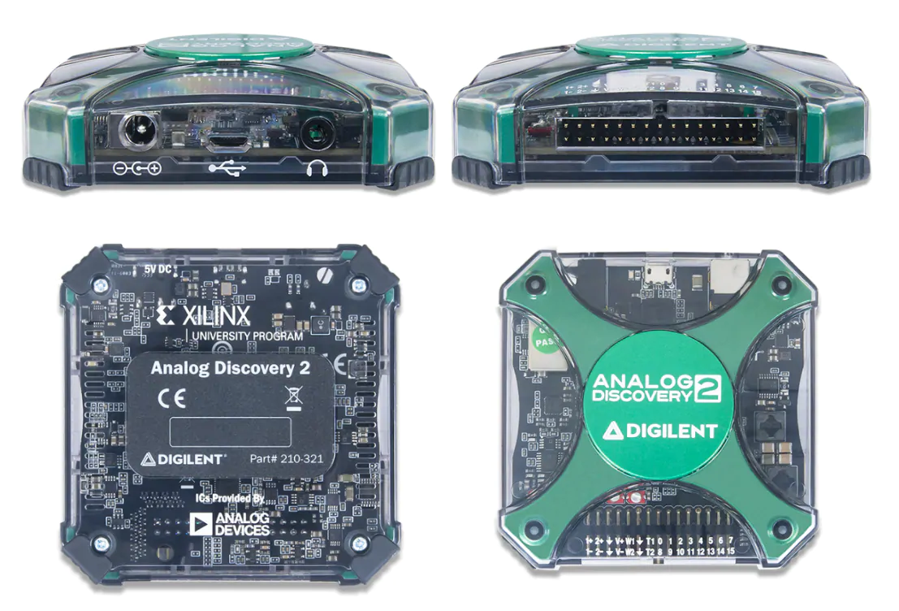

# Introduction

Texas A&M University is known for producing top-tier engineers, and this would not be possible without developing students through top-tier coursework, including Principles of Electrical Engineering (ECEN 215). ECEN 215 is a second year engineering course offered to students in disciplines outside of electrical engineering. It introduces students to the fundamentals of circuit analysis and electronics. The course also includes a laboratory component which allows students to apply what they are learning within the classroom to practical applications. Assignments in the lab include using circuit analysis tools like an oscilloscope and waveform generator to build and analyze DC and AC circuits systems. For one to complete the lab assignments successfully they must have a device that can do everything that the lab manual requires.

Usually the students are provided with an Analog Discovery 2 (AD2) to accomplish assigned tasks; however, with the goal of transitioning ECEN 215 to an online course, using an AD2 is not reasonable. It is impractical to expect students to spend upwards of $300 for a device they would most likely use once in their careers. With this being the case, this team has set out to provide an alternate solution. Our goal is to develop and build a device that will function as a miniature oscilloscope, waveform generator, multimeter, and power supply. The device will also be accompanied by a smartphone app that communicates via Bluetooth and will allow users to be able to set output voltage and signals, interact with and view waveforms, measure outputs, etc. Upon completion of this project the ECEN 215 lab will be able to be done from home at an affordable cost.

## Background

The Analog Discovery 2 is a portable test and measurement device that is used in all ECEN 215 labs. When the course begins at the start of the semester these devices are handed out to students to facilitate their completion of the laboratory assignments. The AD2 includes a two-channel oscilloscope that can capture and display analog signals, a waveform generator that can produce various signal outputs, a power supply to provide adjustable power to a circuit, a multimeter to measure current, voltage, resistance, and more. Although the AD2 is a useful and well-made device that has all the features necessary to perform accurate circuit analysis, it is very expensive and does more than what is needed for the ECEN 215 lab. With this in mind, the ECEN 215 Lab Kit project aims to replace the AD2 within the ECEN 215 laboratories.

The ECEN 215 Lab Kit will be designed specifically for the ECEN 215 lab. This means the device will have no unnecessary or overcomplicated features that are beyond what users need to complete their lab assignments. Another reason for replacing the AD2 is to make ECEN 215 a remote course. If ECEN 215 is going to be a remote course the students need a way to be able to perform the lab remotely, and it is unrealistic to expect students that are not studying electrical engineering to purchase a $300 electrical analysis device like the AD2. Therefore, our product offers another solution, affordability. Our device aims to be priced at $50, 1/6th of the price of the AD2.

## Overview



The ECEN 215 Lab Kit will consist of everything needed to ensure user success when performing the assignments given in the laboratory for this course. The main elements our device will consist of are a two channel oscilloscope, a waveform/signal generator, a multimeter, and a power supply.

The two channel oscilloscope will allow the device to read analog signals from the users’ circuits and display the signals via Bluetooth communication with the mobile app. Once the oscilloscope reads and sends this data to the app, the user will be able to make use of cursors and other tools to further analyze the data. Users will have the ability to use the waveform generator to choose from square, triangle, or sine waves. The multimeter within the device will be able to measure voltage, amperage, and resistance. All values measured by the multimeter will be displayed on screen within the mobile app. Finally, the ECEN 215 Lab Kit will have the ability to produce -5 to 5 volts.

The mobile application will serve as a digital interface, displaying measurements to users either through numerical values or graphs, depending on the chosen operation. Users can select their intended operation and adjust input signals via different menus and read output values. Additionally, the application will offer an option to enable cursors for more detailed information from any graphs.

## Referenced Documents and Standards

* <https://chat.openai.com/>
* <https://www.youtube.com/watch?v=EnfjYwe2A0w>
* <https://www.youtube.com/watch?v=g4BvbAKNQ90>
* <https://www.youtube.com/watch?v=xqgu3VveUrA>
* [Analog Discovery 2 Hardware Design Guide - Digilent Reference](https://digilent.com/reference/test-and-measurement/analog-discovery-2/hardware-design-guide)
* [A High-Performance Open Source Oscilloscope: development log & future ideas](https://www.eevblog.com/forum/testgear/a-high-performance-open-source-oscilloscope-development-log-future-ideas/)
* [What is an Oscilloscope » Electronics Notes](https://www.electronics-notes.com/articles/test-methods/oscilloscope/scope-basics.php)
* [What is a DMM, Digital Multimeter » Electronics Notes](https://www.electronics-notes.com/articles/test-methods/meters/dmm-digital-multimeter.php)
* [Analog Discovery 2 Specifications - Digilent Reference](https://digilent.com/reference/test-and-measurement/analog-discovery-2/specifications)

# Operating Concept

## Scope

This ECEN 215 portable circuit analysis tool will be a cheap and user-friendly alternative to the Analog Discovery 2. It will be able to generate all of the relevant waveform shapes, frequencies, and amplitudes required for the ECEN 215 class, at an affordable price for students at the entry level. Device deliverables for the proposed device are listed below.

* Multimeter (Voltmeter, Ammeter, Ohmmeter)
* Waveform Generator (Produces sin, square, and triangular waves at 1, 20, and 30 Hz, with amplitudes of 0.5 V, 1 V, and 2 V, and an offset of at least 1 V)
* Power Supply (provides at least + and - 5 V to power user’s circuit)
* App (connects to phone via Bluetooth to allow adjustments to input amplitude and frequency, as well as display output readings)
* Intended to be below $50

## Operational Description and Constraints

This device is intended for the ECEN 215 laboratory at Texas A&M University. It will provide the necessary functions of a portable oscilloscope, and will be powered by a standard American wall outlet. The device requires a compatible smart device (to read waveforms and adjust input values) and a breadboard to operate. The device will provide limited flexibility for input waveforms, as it is tailored specifically for ECEN 215 lab to keep the device as affordable as possible. The device is desired to be at, or below, $50.

## Figure 2 - User Circuit BoardSystem Description

**User Circuit Board:** Standard breadboard provided by Texas A&M University in ECEN 215 lab kits. Used to create simple circuits that will be powered and monitored by the portable oscilloscope.

**Wall AC Adapter:** Standard adapter for American wall outlets that will supply power to the device.

**Signal Generator:** Communicates with the microcontroller to adjust signals and generate waveforms with the following minimum capabilities:

* AC Signals - sine, triangular, and square waves ***Figure 3: User Circuit Board***
* AC Input voltage amplitudes - 0.5, 1, and 2 Volts
* AC Frequencies - 1, 20, and 30 Hz
* Power supplies - Provides ± 5 Volts DC

**Multimeter:** Measures instantaneous voltages, currents, and resistances. Communicates with the microcontroller to display measurement readings.

**Oscilloscope:** Reads AC input and output waveforms and communicates with the microcontroller to display waveform signals as a function of time.

**Microcontroller:** Intakes voltages, currents, and resistances from the signal generator, multimeter, and oscilloscope, and “translates them” to the app to display measurements via a graph or number. Intakes signals from the app via Bluetooth and “translates” to the signal generator to increase or decrease voltage signals as necessary. Essentially the microcontroller is a digital interpreter between the system and app to modify and display signals.

**App:** Digital interface that will display measurements to the user via a time-scaled graph or simple number depending on the selected operation. Will have a menu to select the intended operation (i.e. transient waveform, voltmeter, ohmmeter, etc.). Will have another menu to adjust input signals and read output values. Will have a button to enable cursors, to read x and y values on time scaled graphs.

## Modes of Operations

There are three major modes of operation for this project:

* First, the multimeter mode captures either current, resistance, or voltage and displays the measurement on an app.
* Second, the generation mode produces a DC or AC signal through probes. The mode will be capable of producing a square, sine, and triangle wave along with a DC voltage ranging from -5 to +5 V.
* Finally, the oscilloscope mode reads and displays the voltage as a function of time as a graph through the app.

## Users

Students taking the ECEN 215 course will use the ECEN 215 Lab Kit to complete laboratory assignments. The goal of this project is to provide students working on experiments remotely, or outside of the laboratory, with a cheaper alternative to the nearly $300 AD2. ECEN 215 is an introductory course for non-electrical engineering students, therefore, only the lecture and lab manual are required to operate the device. Additional information such as installing the app and operating each instrument will be included in an electronic user manual. The manual will consist of visual aids to simplify instructions.

## Support

Support for the ECEN 215 Lab Kit will be provided as a detailed user manual providing information on device setup, app installation, and usage. The user manual will describe the location of each tool within the app and instructions for each tool’s operation. To minimize confusion, these will be accompanied with visuals.

# Scenario

## ECEN 215 Lab Facilitator

The ECEN 215 Lab Kit will primarily be used by students taking ECEN 215. Therefore the kit’s instruments and specifications are designed to be compatible with labs conducted in ECEN 215. In addition, the ECEN 215 Lab Kit simplifies the process of completing each assignment. Before the user would require a separate power supply, multimeter, waveform generator, and oscilloscope to complete every lab. Even if the user had a device which combined the instruments above, such a device would cost about $300, and with the lab kit, these are combined into a single device expected to cost about $50.

# Analysis

## Summary of Proposed Improvements

* The system will be much cheaper than the previously used AD2
  + Instead of roughly $300, it will ideally be around $50 per unit
* Extra kits will be available in case of unforeseen damages without much extra cost
* The kits will be tailored for ECEN 215 labs with preset values for each lab, leaving little room for error when inputting and extracting data
* There will be an app to accompany the kit that displays graphs and values on any compatible smart device with Bluetooth, as opposed to needing a physical connection to a laptop

## Disadvantages and Limitations

* The system is optimized for ECEN 215 so any modification to the lab curriculum could lead to incomplete or unusable data
* Higher latency from a Bluetooth connection, as opposed to a wired connection, means delayed response time between the kit and the device
* Currently, there are no physical dials or buttons on the device that could be used for the fine-tuning of values
* An external brick will be used as the AC/DC converter taking up more workspace

## Alternatives

* Breaking down the kit into its core components(Oscilloscope, Wave Generator, Voltmeter) and using them separately
  + While the measurements would be more precise and accurate, it would cost significantly more and there are three different devices to worry about instead of one
  + There would be no app where the data could be stored and extracted from, only physical values would be available
* Using an AD2
  + Measurements would be more accurate but the device would be more expensive
  + Students in ECEN 215 would not need a majority of the features offered by the AD2 increasing the likelihood of making errors when looking for certain features

## Impact

* The ECEN 215 Lab Kit improves the course’s accessibility for remote learning
* The low cost of the device allows students to afford the device for personal use or further academic use
* The low manufacturing cost and simplified lab kit reduces the number of different components used in the device

ECEN 215 Lab Kit

Luis Diaz-Santini

Ryan Freed

Yusuf Hossain

Peter Zhang

**Functional System Requirements**

REVISION – Final

27 April 2024

Functional System Requirements

for

ECEN 215 Lab Kit

Prepared by:

_____________________________

Author Date

Approved by:

_____________________________

Project Leader Date

_____________________________

John Lusher, P.E. Date

_____________________________

T/A Date

**Change Record**

| **Rev.** | **Date** | **Originator** | **Approvals** | **Description** |
| --- | --- | --- | --- | --- |
| **-** | 2/12/23 | Luis Diaz-Santini, Peter Zhang |  | Beginning Draft |
|  | 2/19/24 | Luis Diaz-Santini, Peter Zhang |  | Edits |
|  | 2/23/24 | ECEN 215 Lab Kit |  | Final Edits before Midterm Submission |

**Table of Contents**

**Table of Contents III**

**List of Tables IV**

**List of Figures V**

**1.** **Introduction 1**

1.1. Purpose and Scope 1

1.2. Responsibility and Change Authority 2

**2.** **Applicable and Reference Documents 2**

2.1. Applicable Documents 2

2.2. Reference Documents 2

**3.** **Requirements 3**

3.1. System Definition 3

3.2. Characteristics 4

3.2.1. Functional / Performance Requirements 4

3.2.2. Physical Characteristics 5

3.2.3. Electrical Characteristics 6

3.2.4. Environmental Requirements 8

3.2.5. Failure Propagation 8

**4.** **Support Requirements 8**

**Appendix A Acronyms and Abbreviations** **9**

**Appendix B Definition of Terms 1****0**

**Appendix C Interface Control Documents**

**List of Tables**

**Table 1. Member Subsystem Responsibilities 2**

**List of Figures**

**Figure 1. Project Conceptual Image** **1**

**Figure 2. Block Diagram of System 3**

**Figure 3.** **Concept of Application Menus****4**

# 

# Introduction

## Purpose and Scope

At Texas A&M University, Principles of Electrical Engineering (ECEN 215) is taught to engineering students outside of the electrical and computer engineering program. The course teaches the fundamentals of circuit analysis and electronics, which is accompanied by a laboratory (lab) component where students physically build and analyze circuits. However, distance learning students face challenges in completing ECEN 215’s lab portion due to the required instruments' high cost. The ECEN 215 Lab Kit aims to provide a cost-effective alternative to tools traditionally used in these laboratory activities. It will measure and transmit current, resistance, and voltage values to a microcontroller which are subsequently processed and displayed to a smartphone application. For accessibility, the device should cost around $50 and be no larger than a cellular phone. A portable wall charger will power the device. The lab kit will be capable of completing laboratory assignments 1 through 8 by operating as an oscilloscope, a waveform generator, and a multimeter. Figure 1 shows a representative integration of the project in the proposed CONOPS. The verification requirements for the project are contained in a separate Verification and Validation Plan.



## Responsibility and Change Authority

The team leader, Peter Zhang, is responsible for guaranteeing all requirements of the project are met. If any changes are made to these requirements, they must first be approved by the client, Professor John Lusher, and the team leader. The following table identifies each member and the subsystem each is responsible for.

| **Subsystem** | **Responsible Member** |
| --- | --- |
| Mobile Application | Luis Diaz-Santini |
| Oscilloscope and Voltmeter | Peter Zhang |
| PCB Design | Ryan Freed |
| Waveform Generator | Yusif Hossain |
| Microcontroller | Yusif Hossain/Peter Zhang |

***Table 1: Member Subsystem Responsibilities***

# Applicable and Reference Documents

## Applicable Documents

The following documents, of the exact issue and revision shown, were referenced in the design and manufacturing of this product:

* [ChatGPT](https://chat.openai.com/)
* [Electronics Basics ADC](https://www.youtube.com/watch?v=EnfjYwe2A0w)
* [Analog Discovery 2 Hardware Design Guide - Digilent Reference](https://digilent.com/reference/test-and-measurement/analog-discovery-2/hardware-design-guide)
* [A High-Performance Open Source Oscilloscope: development log & future ideas](https://www.eevblog.com/forum/testgear/a-high-performance-open-source-oscilloscope-development-log-future-ideas/)
* [Analog Discovery 2 Specifications - Digilent Reference](https://digilent.com/reference/test-and-measurement/analog-discovery-2/specifications)
* [Creating an App for Interacting with IoT Devices using BLE and FlutterFlow](https://blog.flutterflow.io/creating-an-app-for-interacting-with-any-iot-devices-using-ble/#app-overview)
* [IEEE 802.15.1 Standards](https://standards.ieee.org/ieee/802.15.1/1180/)

## Order of Precedence

In the event of a conflict between the text of this specification and an applicable document cited herein, the text of this specification takes precedence without any exceptions.

All specifications, standards, exhibits, drawings or other documents that are invoked as “applicable” in this specification are incorporated as cited. All documents that are referred to within an applicable report are considered to be for guidance and information only, except ICDs that have their relevant documents considered to be incorporated as cited.

# Requirements

## System Definition

The ECEN 215 Lab Kit is a portable circuit analyzer capable of functioning as an oscilloscope, multimeter, and waveform generator to facilitate ECEN 215’s laboratory component. This device is divided into four primary subsystems, as shown in Figure 2. These subsystems include the multimeter and oscilloscope, waveform generator, PCB, and mobile application. The microcontroller is a minor subsystem primarily shared between the oscilloscope and waveform generator.



The multimeter and oscilloscope subsystems operate in their respective modes. In the oscilloscope mode, the device obtains a signal that displays a transient waveform on the user’s mobile device. The multimeter mode will measure either the current, resistance, or voltage and display the reading on the app. Any processing or transmission of data is handled through the microcontroller. The waveform generator subsystem allows users to output signals such as a DC voltage or a sine, rectangle, and triangle wave, communication to the subsystem and app is provided by the microcontroller. To utilize each instrument, the user will select, on the mobile application, which operation the lab kit will perform. The app wirelessly communicates the chosen function to the microcontroller. Additionally, the app subsystem designs the user interface. Finally, the PCB is responsible for integrating the multimeter, oscilloscope, power supply, and microcontroller into a small and portable device.

## Characteristics

### Functional / Performance Requirements

#### **Mobile Application**

This project aims to provide the end user with an attractive and responsive app that will serve as the user’s interface with the ECEN 215 Lab Kit. The mobile application will communicate with the device via bluetooth. The user will be able to navigate to multiple menus to assist in their circuit analysis. Currently the application will have four menus, oscilloscope, multimeter, signal generator, and power supply. At any time the user can navigate to and between these menus to accomplish the tasks assigned by the lab manual. Within each menu different options will be presented to the user to assist them in the analysis of their system.



#### **Oscilloscope**

The ECEN 215 Lab Kit will be equipped with the ability to read voltage from the user’s circuit and display that data as a function of time to produce a waveform graph. The graph will be displayed via the application on the user’s smartphone. When viewing the waveform the user will have the option to acquire several parameters of data to further analyze the signal being received.

#### **Signal Generator**

Within the application the user can set parameters to output a certain signal to their circuit. The device will have the capability of generating any sine, square, or triangle signals within the frequency range of 1Hz to 30Hz.

*Rationale: The ECEN 215 lab manual states that only square, sine, and triangle signals need to be generated. The lowest frequency needed to be generated is 1Hz and the maximum frequency is 30Hz.*

#### **Multimeter**

The multimeter within the device will be able to read any voltage, resistance, and current that the user’s circuit is outputting. The reading will be displayed on the application in the appropriate menu, and it is up to the user to tell the device what parameter is being measured in order to obtain an accurate reading.

#### **Power Supply**

The power supply will have two voltage outputs -5V and 5V .

*Rationale: The ECEN 215 lab manual only requests a supply of either -5V or 5V.*

### Physical Characteristics

#### **Mass**

The ECEN 215 Lab Kit is aiming to be less than or equal to 8.5 ounces.

*Rationale: The AD2 weighs 8.5 ounces, we aim to be lighter since the lab kit will be a simpler device.*

#### **Volume Envelope**

The volume envelope of the ECEN 215 Lab Kit aims to be less than or equal to 2 inches in height, 3 inches in width, and 6 inches in length.

*Rationale: One of the goals in making this device is to make it extremely portable, and at this size the device would be the size of a smartphone.*

#### **Device Enclosure**

Since the actual device will be a PCB with different components mounted onto it, the device will be enclosed in a protective casing. The casing will be a lightweight but durable plastic perfect for everyday use. The design will ensure quick access to all I/O, while the rounded edges will provide a comfortable grip.

### Electrical Characteristics

#### **Inputs**

##### Power Consumption

The maximum peak power of the system shall not exceed 36W.

##### Input Voltage Level

The input voltage level for the ECEN 215 Lab Kit will be +12V.

*Rationale: To power the device an AC to DC converter that takes 120 VAC and converts it to 12VDC will be used.*

##### Application Input

The signal generation menu of the application will take in user input to output the requested signal generation. Within the power supply menu the user’s input will determine what voltage is supplied. Within the multimeter menu the user’s input will determine what parameter the device measures. Within the signal generator menu the user’s input will determine what type of signal is output to the circuit through the aforementioned probes.

* + - * 1. **Oscilloscope and Multimeter**

The ECEN 215 lab kit will measure circuit parameters using probes and display this input on the oscilloscope menu as a waveform or as a measured value within the multimeter menu. Listed below are the parameters that can be measured using the multimeter.

* **Voltage**
* **Amperage**
* **Resistance**
  + - * 1. **Signal Generator**

As stated before the signal generation is based on the user input within the app. Below are all the listed inputs that the applications requests of the user to be able to generate a desired signal.

* **Signal Type**
* **Signal Amplitude**
* **Signal Frequency**
* **Signal Phase Shift**
* **Signal Offset**

*Rationale: All parameters listed are what is required to generate an output signal.*

#### **Outputs**

##### Oscilloscope Waveform

As the lab kit takes in the voltage from the user’s circuit, a waveform graph will be output on the application. Along with displaying the waveform, the user has the options to view the parameters listed below. For the user to obtain and output these parameters the data received from their circuit will be analyzed by the system and output back out.

##### Amplitude

##### Frequency

##### Time Shift

##### Phase Shift

##### Period

* **Bode Plot**

*Rationale: The ECEN 215 lab only requires the student to measure the parameters listed above.*

##### Measured Values from Multimeter

Depending on user input the device will connect to and read these parameters from the device then output these values to the application. Below are the parameters that the device will be able to output.

* **Voltage**
* **Amperage**
* **Resistance**

*Rationale: The ECEN 215 lab only requires the student to measure the parameters listed above.*

##### Signal Generated

The ECEN 215 Lab Kit will be equipped with the ability to output certain signals, depending on the user’s input in the application. The signal generated will be supplied to the user’s circuit through connections between the device and their circuit.

#### **Connectors**

* + - * 1. **Wall Power**

The ECEN 215 Lab Kit will be powered by household AC power. The device will be furnished with an AC to DC adapter that will be able to connect to any 120VAC US outlet.

* + - * 1. **Leads**

The ECEN 215 Lab Kit will come with several leads, in black and in red. These leads will be used to communicate and transfer any voltage, signals, or circuit information between the device and the user’s circuit board.

#### **Wiring**

The only wiring that will be present on the system will be the aforementioned leads, probes, and wall power cord. The internals of the system will be integrated on a PCB, meaning there is no need for internal wiring.

### Environmental Requirements

The ECEN 215 Lab Kit shall be designed to operate in the causal environments and laboratory settings where there is not much external strain introduced to the device.

*Rationale: Most students will use this device in a casual, household setting.*

#### **Thermal**

No components of the ECEN 215 Lab Kit will be consuming enough power that would lead the device to overheat. That being said the heat being output by each component in the device will not be enough that would cause the device to run hotter than room temperature.

#### **Weather**

The ECEN 215 Lab Kit is intended for indoor use only and will not be rated to withstand water damage. The device will be designed to withstand temperatures from -40 degrees celsius to 105 degrees celsius.

### Failure Propagation

Since the ECEN 215 Lab Kit is a small scale device there is not much to be done besides restarting the system if it were to crash or become unresponsive. In the case of a crash the device will have a RESET button that the user can press at any time to power cycle the system.

# Support Requirements

The ECEN 215 Lab Kit requires a Bluetooth connection to display measured values. Users must provide a device capable of both Bluetooth connectivity and downloading mobile applications. The application will support both Android and IOS devices. Support regarding installing or connecting with the mobile application will be included in the user manual. The lab kit consists of an oscilloscope, an ammeter, an ohmmeter, a voltmeter, a waveform generator, an AC adapter, and a microcontroller. While an AC adapter is included in the kit, continuous access to a wall outlet is required for the device to operate.

# Appendix A: Acronyms and Abbreviations

AC Alternating Current

AD2 Analog Discovery 2

DC Direct Current

ECEN Electrical and Computer Engineering

Hz Hertz

I/O Input/Output

PCB Printed Circuit Board

VAC Measured Alternating Current Voltage

VDC Measured Direct Current Voltage

W Watts

# Appendix B: Definition of Terms

No terms need to be defined at this time.

ECEN 215 Lab Kit

Luis Diaz-Santini

Ryan Freed

Yusuf Hossain

Peter Zhang

**Interface Control Document**

REVISION – Final

27 April 2024

Interface Control Document

for

ECEN 215 Lab Kit

Prepared by:

_____________________________

Author Date

Approved by:

_____________________________

Project Leader Date

_____________________________

John Lusher II, P.E. Date

_____________________________

T/A Date

**Change Record**

| **Rev.** | **Date** | **Originator** | **Approvals** | **Description** |
| --- | --- | --- | --- | --- |
| **-** | 2/12/23 | Ryan Freed, Yusuf Hossain |  | Beginning Draft |
|  | 2/19/24 | Ryan Freed, Yusuf Hossain |  | Edits |
|  | 2/23/24 | ECEN 215 Lab Kit |  | Final Edits before Midterm Submission |

**Table of Contents**

**Table of Contents III**

**List of Tables IV**

**List of Figures V**

[**1.** **Overview 1**](https://docs.google.com/document/d/1EQcRD-T1blzSj1Mo4glEttvNUKty3c2g/edit#heading=h.4d34og8)

[**2.** **References and Definitions**](https://docs.google.com/document/d/1EQcRD-T1blzSj1Mo4glEttvNUKty3c2g/edit#heading=h.2s8eyo1) 1

[2.1. References](https://docs.google.com/document/d/1EQcRD-T1blzSj1Mo4glEttvNUKty3c2g/edit#heading=h.17dp8vu) 1

[2.2. Definitions](https://docs.google.com/document/d/1EQcRD-T1blzSj1Mo4glEttvNUKty3c2g/edit#heading=h.3rdcrjn) 1

[**3.** **Physical Interface**](https://docs.google.com/document/d/1EQcRD-T1blzSj1Mo4glEttvNUKty3c2g/edit#heading=h.lnxbz9) **1**

[3.1. Weight](https://docs.google.com/document/d/1EQcRD-T1blzSj1Mo4glEttvNUKty3c2g/edit#heading=h.35nkun2) 1

3.2. Dimensions 2

[3.2.1. Dimension of subsystem name](https://docs.google.com/document/d/1EQcRD-T1blzSj1Mo4glEttvNUKty3c2g/edit#heading=h.1ksv4uv) 2

[3.3. Mounting Locations](https://docs.google.com/document/d/1EQcRD-T1blzSj1Mo4glEttvNUKty3c2g/edit#heading=h.44sinio) 2

[**4.** **Thermal Interface**…………………………………………………………………………….](https://docs.google.com/document/d/1EQcRD-T1blzSj1Mo4glEttvNUKty3c2g/edit#heading=h.3j2qqm3)**2**

**5.** **Electrical Interface 3**

[5.1. Primary Input Power](https://docs.google.com/document/d/1EQcRD-T1blzSj1Mo4glEttvNUKty3c2g/edit#heading=h.4i7ojhp) 3

[5.2. Voltage and Current Levels](https://docs.google.com/document/d/1EQcRD-T1blzSj1Mo4glEttvNUKty3c2g/edit#heading=h.2xcytpi) 3

[5.3. Signal Interfaces](https://docs.google.com/document/d/1EQcRD-T1blzSj1Mo4glEttvNUKty3c2g/edit#heading=h.1ci93xb) 4

[5.4. User Control Interface 4](https://docs.google.com/document/d/1EQcRD-T1blzSj1Mo4glEttvNUKty3c2g/edit#heading=h.1ci93xb)

**6****.** **Communications / Device Interface Protocols 4**

6[.1. Bluetooth 4](https://docs.google.com/document/d/1EQcRD-T1blzSj1Mo4glEttvNUKty3c2g/edit#heading=h.4i7ojhp)

6[.2. Microcontroller Input and Output 4](https://docs.google.com/document/d/1EQcRD-T1blzSj1Mo4glEttvNUKty3c2g/edit#heading=h.2xcytpi)

**List of Tables**

**Table 1: Weight Specifications………….…….…………………………………………………1**

**Table 2: Dimension Specifications…..……….……………………………………....………...1**

**Table 3: Voltage and Current Levels…………………………………………….………………6**

**List of Figures**

**Figure 1: Electrical Systems Block Diagram………………….………………………………6**

# Overview

The Interface Control Document for the ECEN 215 Lab kit will cover the physical description and characteristics of each component used, the connectivity between each subsystem, power requirements for the whole kit, and communication between the user and the board.

# References and Definitions

## References

The following documents/resources, of the exact issue and revision shown, were referenced in the design and manufacturing of this product:

* ChatGPT - <https://chat.openai.com/>
* [Electronic Basics #27: ADC (Analog to Digital Converter)](https://www.youtube.com/watch?v=EnfjYwe2A0w)
* [Analog Discovery 2 Hardware Design Guide - Digilent Reference](https://digilent.com/reference/test-and-measurement/analog-discovery-2/hardware-design-guide)
* [A High-Performance Open Source Oscilloscope: development log & future ideas](https://www.eevblog.com/forum/testgear/a-high-performance-open-source-oscilloscope-development-log-future-ideas/)
* [Analog Discovery 2 Specifications - Digilent Reference](https://digilent.com/reference/test-and-measurement/analog-discovery-2/specifications)
* [Creating an App for Interacting with IoT Devices using BLE and FlutterFlow](https://blog.flutterflow.io/creating-an-app-for-interacting-with-any-iot-devices-using-ble/#app-overview)
* <https://standards.ieee.org/ieee/802.15.1/1180/>

## Definitions

N/A

# Physical Interface

## Weight

One of the key design features of the ECEN 215 Lab kit is to ease the process of completing the labs at home. This means that the device must be portable and comfortable to carry around. With a small and light frame both of these can be accomplished.

| **System** | **Weight** |
| --- | --- |
| DAC (AD9833BRMZ) | 0.005051oz |
| ESP32-WROOM-32D | 0.257 oz |
| ADC (TLC5540) | 0.007478 oz |

***Table 1: Weight Specifications***

## Dimensions

Making the lab kit as compact as possible without cutting corners in any of the subsystems is the goal. Ideally, the whole system would fit on a PCB and frame no bigger than the average smartphone, these dimensions are 152mm x 76mm.

| **System** | **Length** | **Width** |
| --- | --- | --- |
| DAC (AD9833BRMZ) | 18mm | 17mm |
| ESP32-WROOM-32D | 3mm | 3mm |
| ADC (TLC5540) | 7.8mm | 4.4mm |

***Table 2: Dimension Specifications***

### Dimension of Power System

Having the AD/DC converter on the PCB could cause unwanted noise and can generate excess heat damaging neighboring components, because of this it is best to have it as an external component. The dimensions for the external power brick are TBD.

## Mounting Locations

The entire circuit will be mounted onto a PCB that has not been designed yet. The lab kit will also contain ports that can be used for wire, leads, or probes. There will also be a port for the power connector. After the PCB is designed and all the ports are accounted for the circuit will be placed in a shell that has yet to be designed.

# Thermal Interface

There are no plans for a thermal interface at this time, however, in the future, we may include air vents on the casing of the board.

# Electrical Interface

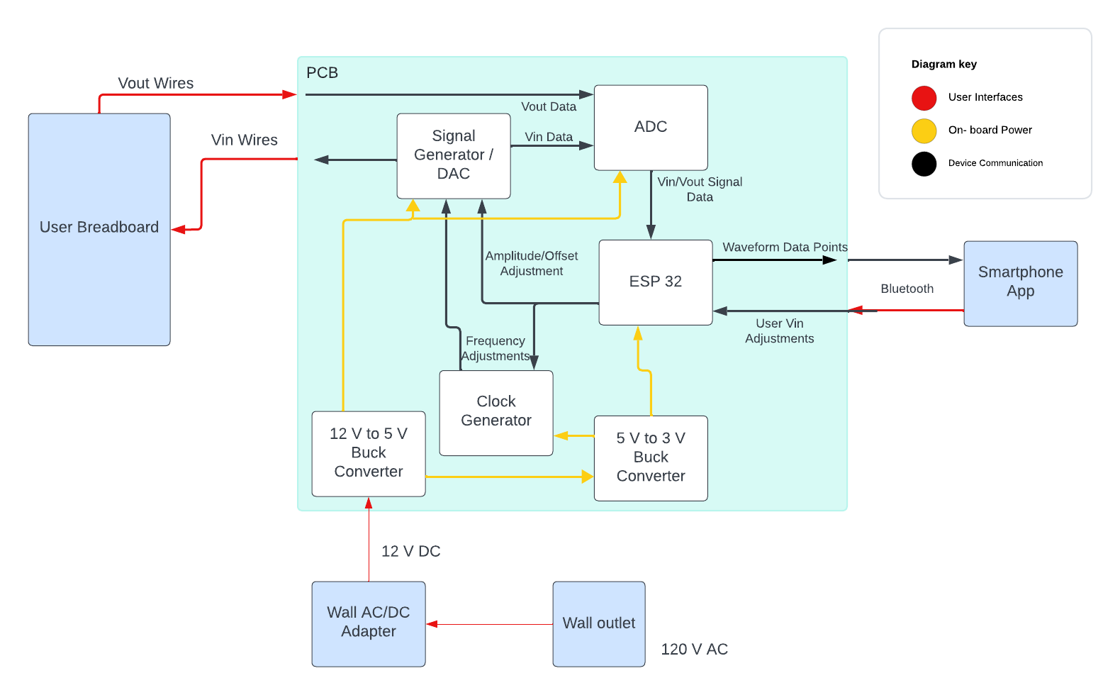

***Figure 1: Electrical Systems Block Diagram***

## Primary Input Power

For user convenience, the kit will come with an AC/DC wall adapter for standard American wall outlets that will directly plug into the kit. The adapter will be rated for 12V/3A. The 12V taken at input will run through a buck converter that will drop down the voltage to both 5 and 3 V for use in the ESP32, Signal generator, Clock, and ADC.

## Voltage and Current Levels

| **System** | **Input Voltage Range** | **Input Current (idle)** | **Input Current (max)** |
| --- | --- | --- | --- |
| DAC (AD9833BRMZ) | 2.3-5.5 V | 4.5 mA | 5.5 mA |
| ESP32-WROOM-32D | -0.3-3.6 V | 0.5 A | 1.1 A |
| ADC (TLC5540) | 4.75-5.25 V | 17 mA | 27 mA |
| Clock | 1.62-3.63 V | 6 mA | 10 mA |

***Table 3: Voltage and Current Levels***

## Signal Interfaces

All chips will be mounted to a PCB and will be controlled via signals set from pins on the microcontroller. The Signal generator, however, must also communicate with the Clock generator, which will be responsible for controlling the frequency of the signal.

## User Control Interface

The user will control this device through a mobile application. The app will give access to input voltage waveform settings such as amplitude, frequency, and shape, and will allow the user switch between modes of operation such as, scope, waveform generator, multimeter, and power supply.

* Scope will allow the user to view the transient response of the input and output waveforms, as well as measure the time and frequency during the response.
* Waveform generator will allow the modification of the input waveform attributes.
* Multimeter will allow the measurement of voltage, current, and resistance.
* Power supply will allow the user to enable the +5 and -5 volt supply lines.

# Communications / Device Interface Protocols

## Bluetooth

A mobile phone app will be responsible for accepting user selections through a user interface and will transmit the signal to the ESP32 microcontroller (see Section 6.2) via Bluetooth (BQB Certified). User operation modes will include, power supply, oscilloscope, voltmeter, ammeter, ohmmeter, and waveform generator (User operation modes further detailed in Section 5.5).

## Microcontroller Input and Output

The ESP32 microcontroller will be responsible for all internal communications. The ESP32 will receive signals via Bluetooth (see section 6.1) and transmit signals to the appropriate systems to manipulate the associated voltage signal.

ECEN 215 Lab Kit

Luis Diaz-Santini

Ryan Freed

Yusuf Hossain

Peter Zhang

**Schedule and Validation**

**Validation Plan**

| **Test** | **Owner** | **Status** | **Success Criterion** |
| --- | --- | --- | --- |
| Buck Converter 12 -> 5 V | RF | Unsuccesful | Intakes 12 V DC outputs 5 V DC |
| Buck Converter 5 -> 3 V | RF | Succesful | Intakes 5 V DC outputs 3 V DC |
| Producing -5 V | RF | Incomplete | Device can be triggered to produce -5 V |
| Wave Gen Powers On | YH | Succesful | Outputs voltage when provided 5 V supply power |
| Wave Gen Amplitude | YH | Incomplete | Outputs 0.5, 1, and 2 V successfully |
| Wave Gen Frequency | YH | Succesful | Outputs frequencies 1, 20, and 30 Hz |
| Wave Gen Output Shape | YH | Succesful | Produces sine, square, and triangular waves at all 3 amplitudes and frequencies |
| Wave Gen Noise | YH | Incomplete | Output signal is moderately accurate |
| Ammeter | PZ | Succesful | Current reading is functional and accurate |
| Ohmmeter | PZ | Succesful | Resistance reading is functional and accurate |
| Duty Cycle | YH | Incomplete | Can produce a square wave with 50% duty cycle |
| Clock Oscillator Power 1 | Team | Incomplete | ADC clock operates as expected with input specifications |
| Clock Oscillator Power 2 | Team | Incomplete | DAC clock operates as expected with input specifications |
| Clock Oscillator 2 Communication | Team | Incomplete | Clock frequency changes change wave gen amplitude as expected |
| App Connects to Bluetooth | LDS | Succesful | App connects to ESP32 |
| App Receives/Sends Data from/to ESP32 | LDS | Succesful | ESP32 reacts to commands sent from the app / App displays message from ESP32 |
| App - Multimeter Function | LDS + PZ | Incomplete | App displays correct parameter with correct value |
| App - Oscilloscope Function | LDS + PZ | Incomplete | App displays accurate graph and can display requested parameters |
| App - Waveform Gen Function | LDS + YH | Incomplete | App takes in appropriate settings and communicates with ESP32 to output correct signal |
| App - Power Supply Function | LDS + RF | Incomplete | App triggers Lab Kit to output power |
| Switching Menus Within App | LDS | Succesful | Can switch to a different menu within app while not disabling previous action |
| App Works on IOS | LDS | Succesful | App is downloaded and operates with all functionality |
| App Works on Android | LDS | Succesful | App is downloaded and operates with all functionality |
| ADC Power | PZ | Succesful | ADC powers on and interprets analog signal into binary output correctly |
| ADC Speed | PZ | Unsuccesful | ADC reads voltages fast enough to produce a smooth sine wave of at least 60 Hz |
| ADC Amplitude | PZ | Succesful | ADC can read between 0 and 5 V |
| ESP32 Power | RF | Succesful | Turns on with correct input signals |
| ESP32 Communicates With App | Team | Incomplete | ESP32 communicates via Bluetooth and sends/receives data from the app |
| ESP32 Communicates With Wave Gen | Team | Incomplete | ESP32 sends correct information to waveform generator |
| ADC Communicates With ESP32 | Team | Incomplete | ESP32 correctly reads digital input from ADC |
| ESP32 Communicates With Power Supply | Team | Incomplete | ESP32 triggers circuit to output power |
| Kit runs at max current/voltage for 30 minutes | Team | Incomplete | Kit can run at max outputs for extended period of time without catastrophic device failure or inappropriately excess noise |

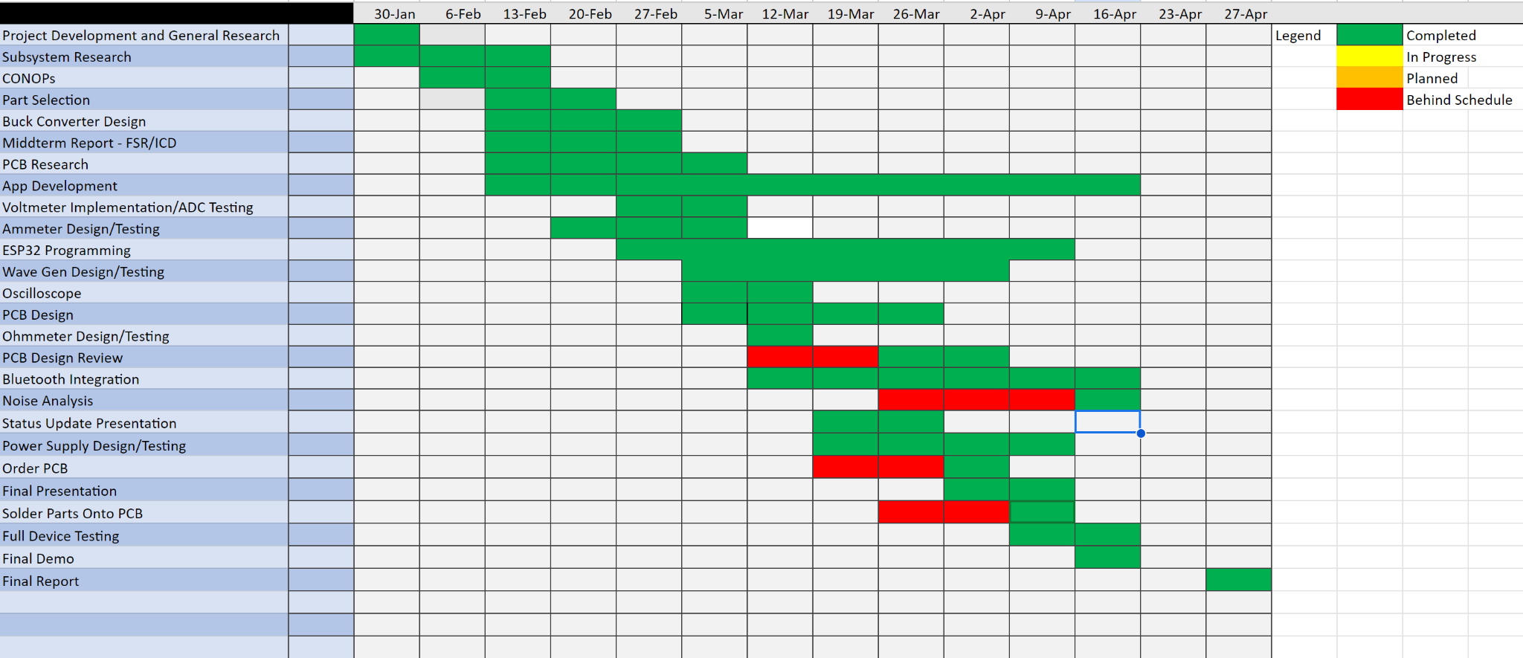

ECEN 215 Lab Kit

Luis Diaz-Santini

Ryan Freed

Yusuf Hossain

Peter Zhang

**Subsystem reports**

REVISION – Final

27 April 2024

Subsystem Reports

for

ECEN 215 Lab Kit

Prepared by:

_____________________________

Author Date

Approved by:

_____________________________

Project Leader Date

_____________________________

John Lusher II, P.E. Date

_____________________________

T/A Date

**Change Record**

| **Rev.** | **Date** | **Originator** | **Approvals** | **Description** |
| --- | --- | --- | --- | --- |
| **-** | 4/20/23 | ECEN 215 Lab Kit |  | Beginning Draft |
|  | 4/24/24 | ECEN 215 Lab Kit |  | Edits |
|  | 4/26/24 | ECEN 215 Lab Kit |  | Edits |
|  | 4/27/24 | ECEN 215 Lab Kit |  | Final Edits before Final Submission |

**Table of Contents**

**Table of Contents III**

**List of Tables IV**

**List of Figures V**

[**1.** **Introduction 1**](https://docs.google.com/document/d/1EQcRD-T1blzSj1Mo4glEttvNUKty3c2g/edit#heading=h.4d34og8)

[**2.** **Board Design and Power Report**](https://docs.google.com/document/d/1EQcRD-T1blzSj1Mo4glEttvNUKty3c2g/edit#heading=h.2s8eyo1) **2**

[2.1. Subsystem Introduction](https://docs.google.com/document/d/1EQcRD-T1blzSj1Mo4glEttvNUKty3c2g/edit#heading=h.17dp8vu) **2**

[2.2. Subsystem Details](https://docs.google.com/document/d/1EQcRD-T1blzSj1Mo4glEttvNUKty3c2g/edit#heading=h.3rdcrjn) **2**

[2.3. Subsystem Validation](https://docs.google.com/document/d/1EQcRD-T1blzSj1Mo4glEttvNUKty3c2g/edit#heading=h.3rdcrjn) **3**

[2.4. Subsystem Conclusion](https://docs.google.com/document/d/1EQcRD-T1blzSj1Mo4glEttvNUKty3c2g/edit#heading=h.3rdcrjn) **6**

[**3.**](https://docs.google.com/document/d/1EQcRD-T1blzSj1Mo4glEttvNUKty3c2g/edit#heading=h.lnxbz9) **Mobile Bluetooth Application**……………………………………………………………….**6**

3.1[. Subsystem](https://docs.google.com/document/d/1EQcRD-T1blzSj1Mo4glEttvNUKty3c2g/edit#heading=h.3rdcrjn) Introduction……………………………………………………………………**6**

3.2. Creating Application..……………………………………………………………………..**6**

3.2.1. Application Pages…………………………………………………………………….**6**

3.2.2 Emulating Application………………………………………………………………..**7**

3.3 Implementation of Bluetooth Low Energy……………………………………………..**9**

3.3.1. Custom Code…………………………………………………………………………**9**

3.3.2. Debugging…………………………………………………………………………...**10**

3.3.3. Testing Communication…………………………………………………………….**10**

3.4 Subsystem Conclusion………………………………………………………………...**12**

**4**[**.**](https://docs.google.com/document/d/1EQcRD-T1blzSj1Mo4glEttvNUKty3c2g/edit#heading=h.lnxbz9) **Wavegen and MCU**……………………………………………………………………………

4.1 Subsystem Introduction…………………………………………………………………**12**

4.2 Firmware and hardware………………………………………………………………...**13**

4.3 Software………………………………………………………………………………….**13**

4.4 Wavegen…………………………………………………………………………………**13**

4.5 Communication………………………………………………………………………….**16**

4.6 Conclusion……………………………………………………………………………….**17**

**5**[**.**](https://docs.google.com/document/d/1EQcRD-T1blzSj1Mo4glEttvNUKty3c2g/edit#heading=h.lnxbz9) **Oscilloscope and Multimeter**………………………………………………………………**17**

5.1 Subsystem Introduction…………………………………………………………………**17**

5.2 Firmware and Hardware……………………………………………………………..…**17**

5.3 Software……………………………………………………………………………….…**18**

5.4 Oscilloscope……………………………………………………………………………..**18**

5.5 Multimeter……………………………………………………………………………..…**18**

5.6 Hardware Communication……………………………………………………...………**19**

5.7 Conclusion……………………………………………………………………….………**20**

**List of Tables**

[**1.** **Table 1: Expected Current Draw of Major ICs**……………………………………………](https://docs.google.com/document/d/1EQcRD-T1blzSj1Mo4glEttvNUKty3c2g/edit#heading=h.4d34og8)**5**

**List of Figures**

**Figure 1: Simplified Diagram of PCB Make-up and Power**……………………………….…**2**

**Figure 2: Testing AC Adapter Power Delivery**…..………..……………………………..……**3**

**Figure 3: Testing 3.3 V Buck Operation and Stability**…..…..…………………….…………**4**

**Figure 4: Testing 3.3 V bBuck Delivery to ESP and Power Plane**…………………………**4**

**Figure 5: 3.3 V Buck (post-fault) and Flux Believed to be the Source of the Fault**….....**5**

**Figure 6: Application Storyboard**………………………………………………………………..**7**

**Figure 7: Application Code in Visual Studio Code**…………………………………………...**8**

**Figure 8: Application Running on Android Emulator**………………………………………..**8**

**Figure 9: Custom Code within FlutterFlow Project**…………………………………………..**9**

**Figure 10: Custom Code Implementation**…………………………………………………….**10**

**Figure 11: Application Demo Page Sending and Receiving Messages**…………………**11**

**Figure 12: ESP32 Sending and Receiving Messages within Arduino IDE**……………...**12**

**Figure 13: ESP32 SINE Generation Code**…………………………………………………… **14**

**Figure 14: SINE Wave with amplitude of 1V and Frequency of 1Hz**……………………. **14**

**Figure 15: Square Wave with amplitude of 1V and Frequency of 1Hz**…………………..**15**

**Figure 16: Triangle Wave with amplitude of 1V and Frequency of 1Hz**…………………**15**

**Figure 17: BLE server Generation**……………………………………………………………..**16**

**Figure 18: Bluetooth Connection**……………………………………………….……………..**16**

**Figure 19: Voltmeter Measurements**…………………………………………………………..**19**

**Figure 20: BLE Server and Communication to App**………………………………………..**19**

1. **Introduction**

The ECEN 215 Lab Kit is a portable and cheap device for students taking the course Principles of Electrical Engineering (ECEN 215). The device will perform as an oscilloscope, a multimeter, and a waveform generator. It will also be accompanied by a smartphone app that communicates via Bluetooth for users to be able to operate the waveform generator or measure outputs. The system is broken down into the following subsystems: board design and power, mobile bluetooth application, wavegenerator and MCU, and multimeter and oscilloscope. Since each subsystem was validated to be working properly and fulfilling all requirements, there is a clear path to integration for these subsystems into the full system specified in the Concept of Operations, Functional System Requirements, and Interface Control Document.

1. **Board Design and Power Report**
   1. ***Subsystem Introduction***

The board design and power subsystem is responsible for uniting all physical aspects of the device under production, including ensuring proper communication between devices, powering all on board components, maintaining size restrictions, and finally assembly of all board components onto the PCB. The PCB is powered primarily by a standard 12 V, 3 A, barrel jack, AC adapter that plugs directly from a wall outlet and into the board. The AC adapter then leads to 3 separate converters that provide 5 V, 3.3 V, and -5 V. The power system was tested for reliability and consistency as well as to test the efficacy of the design and assembly of the board.

* 1. ***Subsystem Details***

A block diagram of the proposed board design and interactions is included below.



***Figure 1: Simplified Diagram of PCB Make-up and Power***

The communication between ICs and board assembly proved to be the most challenging aspects of this subsystem. There are many specific cases and interactions between devices to consider that occur during the ECEN 215 labs. Ensuring that each case’s communication demands were met when designing the board took much deep consideration, and there were a few times where other subsystems had to pick new ICs because of incompatible communication or specifications, leading to the redesign of both the board and redesigns for other subsystems, therefore this subsystem went through a number of revisions, and will likely continue to do so in the future.

Furthermore, assembly of on board components proved to be an incredibly difficult task. To meet the desired size specifications of the device under production, suitably small components had to be selected to reflect these demands. The quantity and size of components provided a notable challenge in assembling the board, and unexpected faults in production occurred along the way.

Additional tasks associated with this subsystem include learning Altium design and soldering, selecting all small scale intermediate components (i.e. resistors, capacitors, inductors, etc.), determining the PCB I/O methods and components to facilitate these interactions, and design of a switching system for a +5 and -5 I/O wire.

* 1. ***Subsystem Validation***

The first validated specification was the device size. The sponsor requested for the device under production to be about the same dimensions of a phone. This requirement was very close to being met, however it ended up a few millimeters wider than desired. This specification will be revisited in the future once further assembly experience is attained in order to meet the goal with room for device casing. Next was a test of the 12 V DC power jack that was selected to deliver power from the AC adapter. The AC adapter was a standard 12 V/5 A adapter that delivered about 12.6 volts to the board successfully.

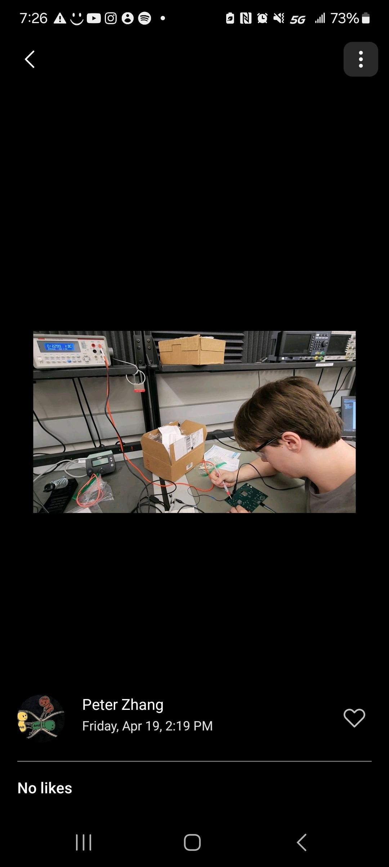

***Figure 2: Testing AC Adapter Power Delivery***

Following up on this test, the 3.3 V buck was checked for overall performance. The 3.3 V buck performed well initially, and provided close to an exact 3.3 volts to the board.

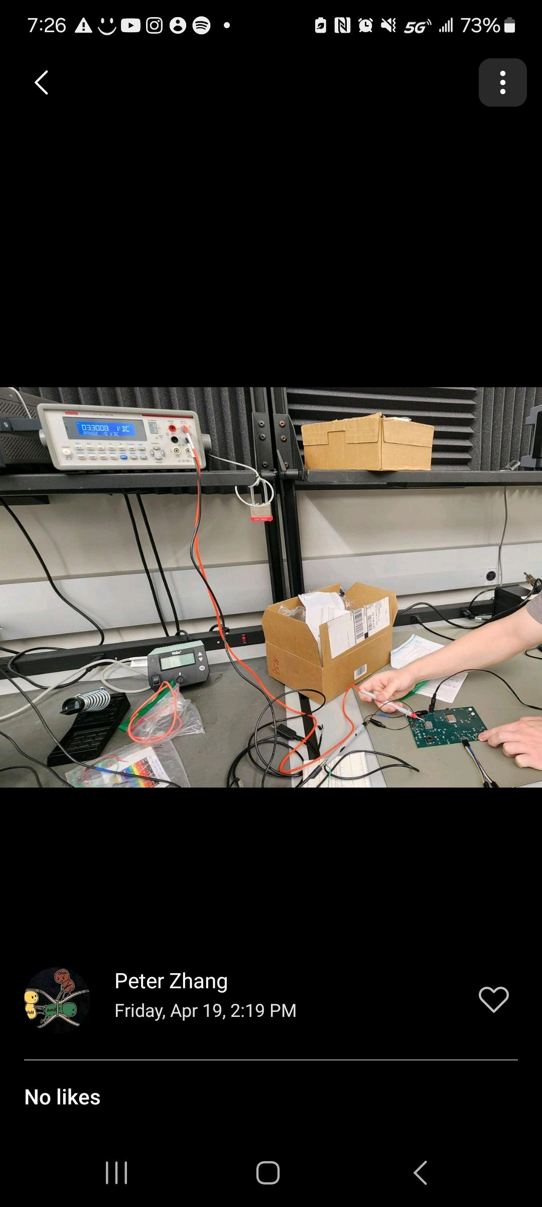  
***Figure 3: Testing 3.3 V Buck Operation and Stability***

In addition, power was delivered to the ESP microcontroller with only a slight drop, activating the ESP at a voltage of approximately 3.27 volts.

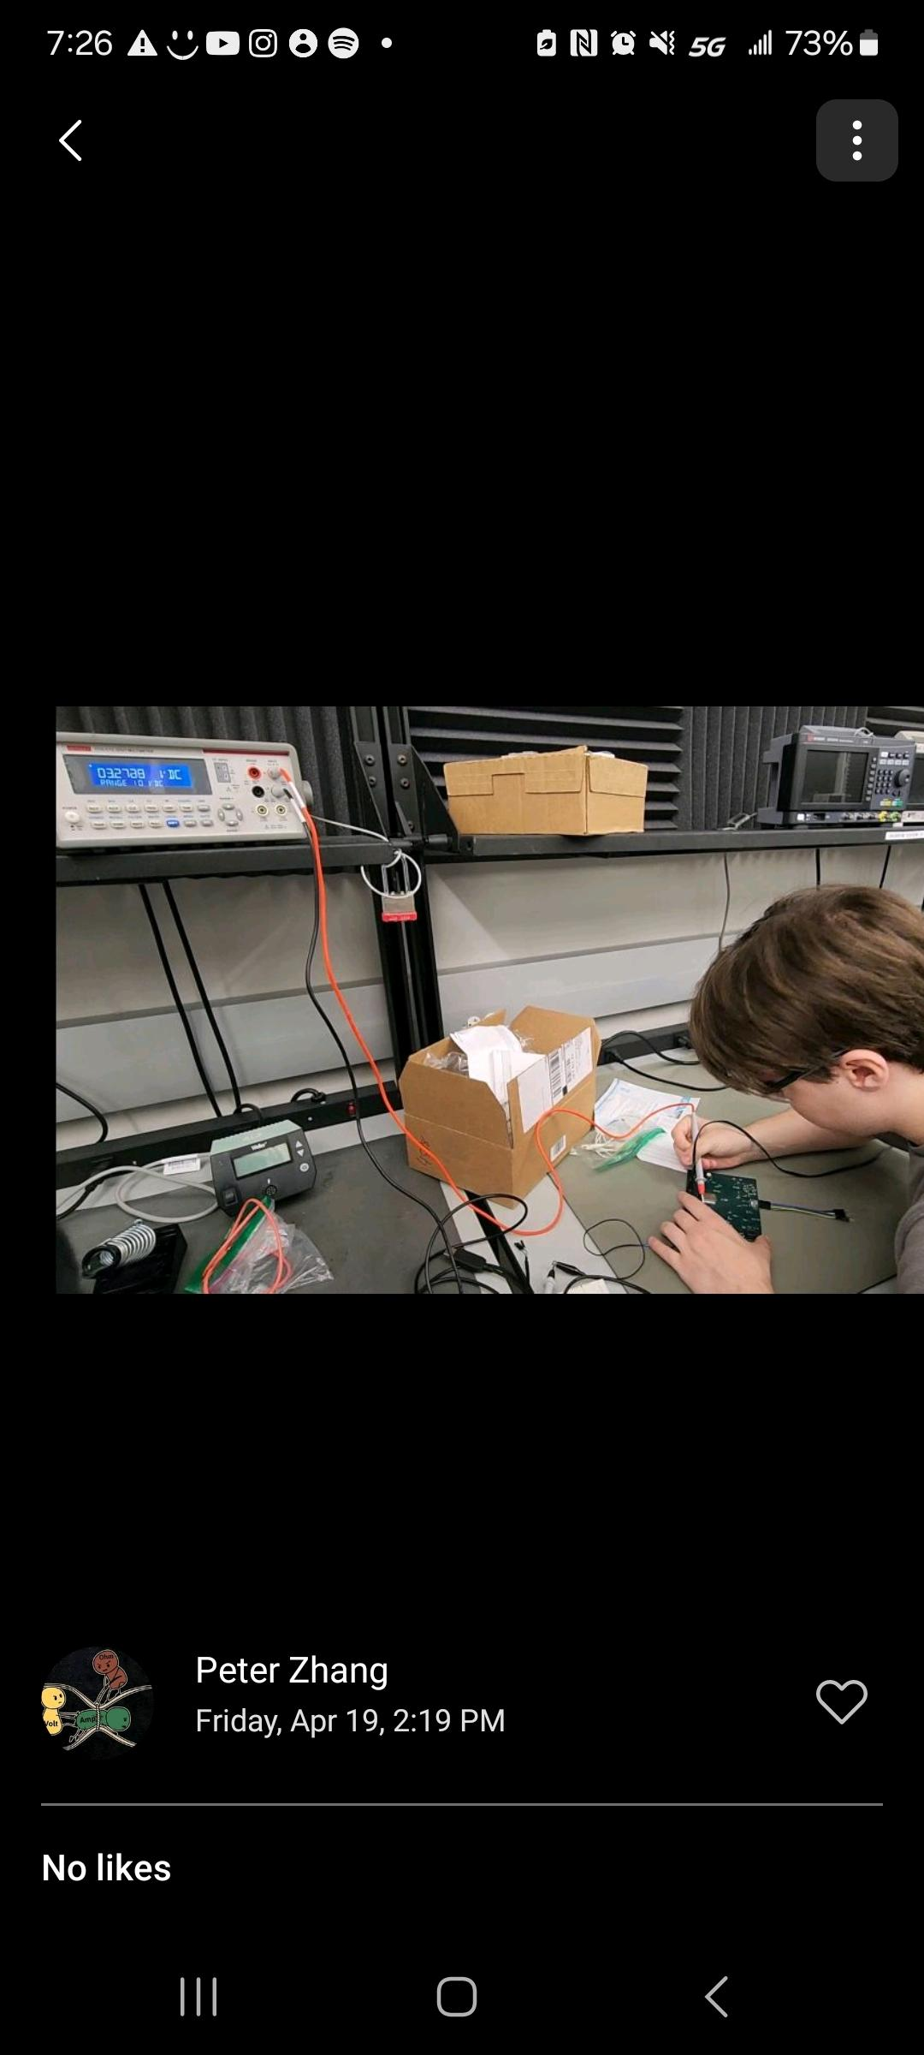

***Figure 4: Testing 3.3 V Buck Delivery to ESP and Power Plane***

Communication with the ESP ensued with only a slight hitch detailed further below in one of the other subsystem reports.

Unfortunately, the 5 V buck did not meet expectations, and provided a voltage in the range of 0.3 V to its respective power plane. Unfortunately, this buck converter provides for the majority of the devices on the board, so some adjustments were necessary to perform further design verification. The expected source of the fault was determined as inadequate component soldering, as the on board components were quite small and numerous. Correction of this assembly mistake was attempted, but upon testing the effectiveness of the change the 3.3 V buck that was previously working near flawlessly burned out. The origin of the new fault was decided to be a result of the flux applied to the board upon resoldering.

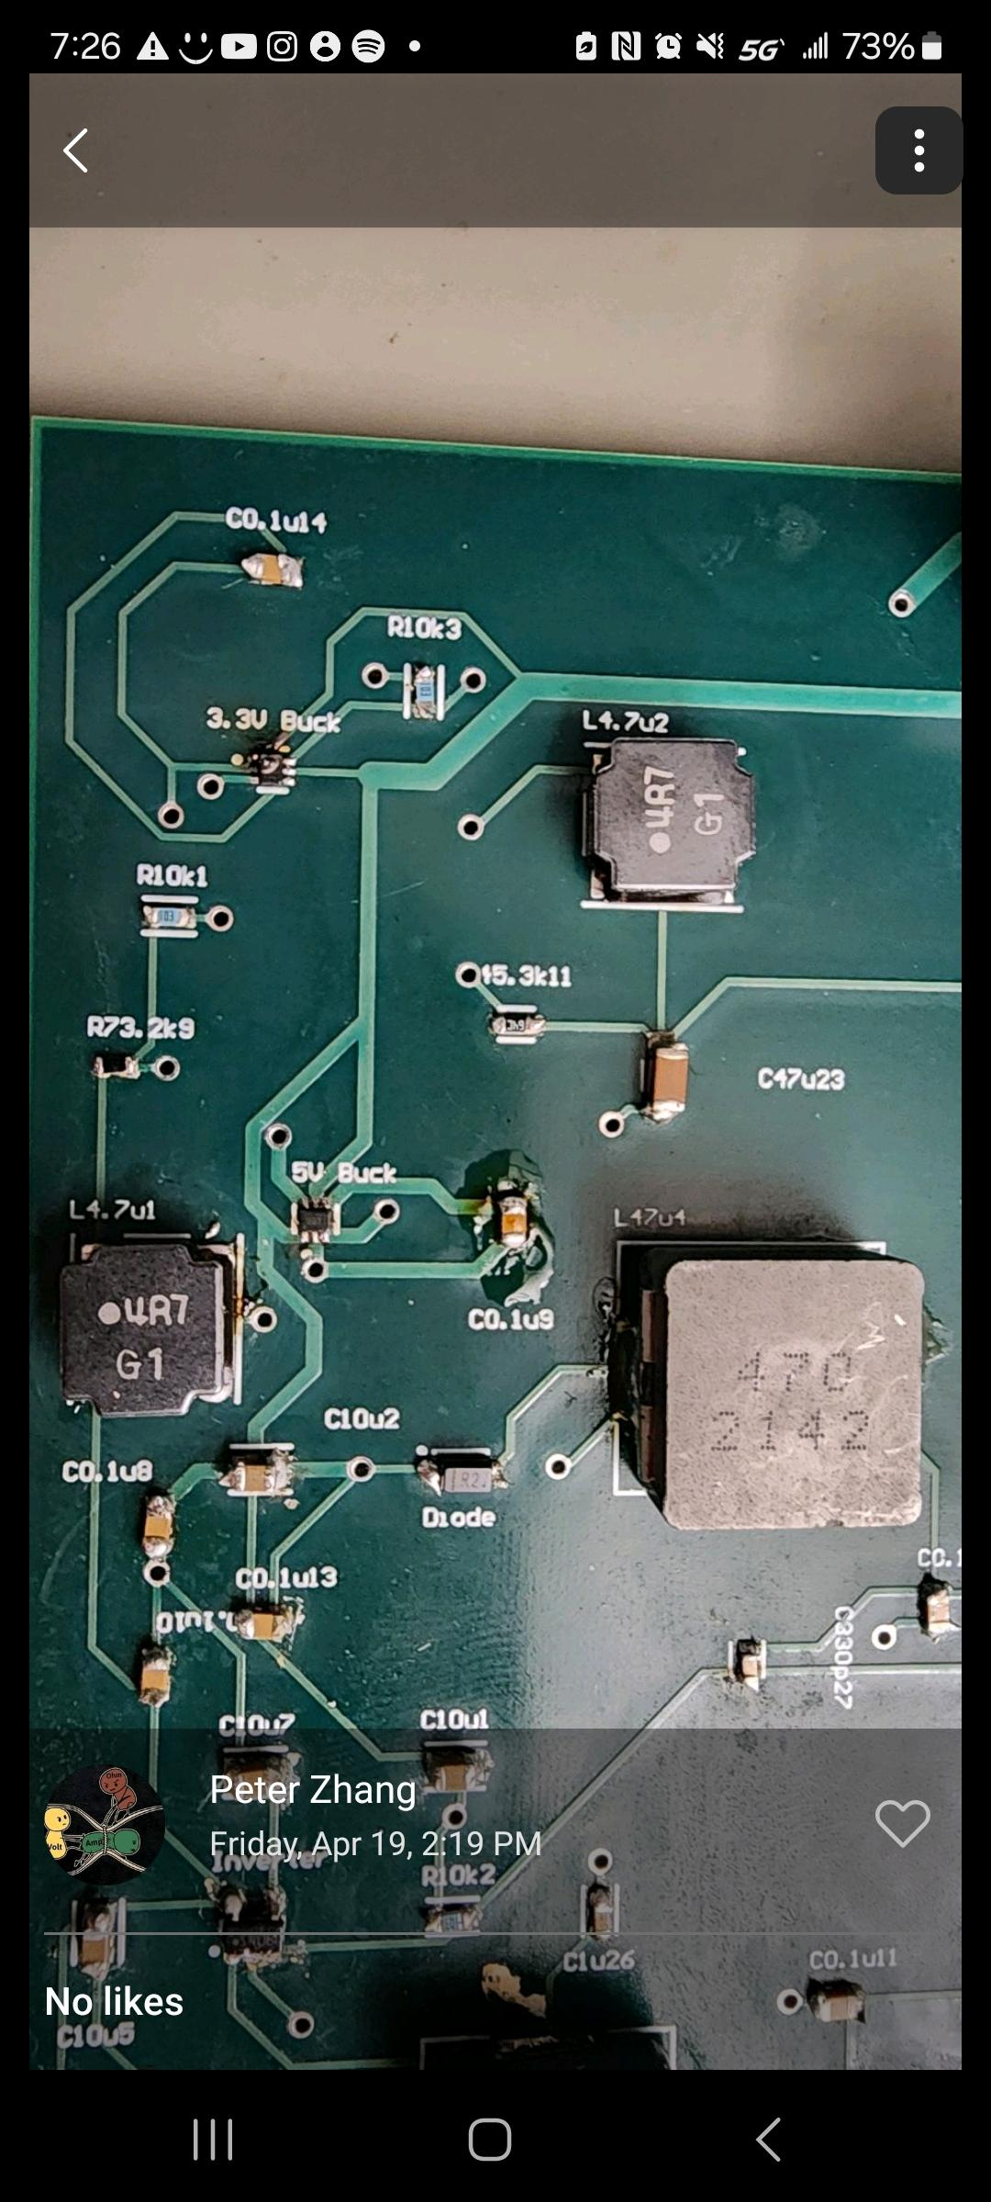

***Figure 5: 3.3 V Buck (post-fault) and Flux Believed to be the Source of the Fault***

In order to overcome this large design concern, and pinpoint the cause of the issue, 5 V was forced into the 5 V power plane through use of a power supply and probe stuck into a via leading to the plane. The resulting conclusion was similar to the buck results, with a small voltage to the plane. Upon further examination it was noted that a higher than expected current was being drawn from the power supply by the plane, that seemed to only be limited to the current setting of the power supply. The current draw from the supply is higher than the expected max current further validating this examination.

| **System** | **Input Voltage Range** | **Input Current (idle)** | **Input Current (max)** |
| --- | --- | --- | --- |
| DAC (AD9833BRMZ) | 2.3-5.5 V | 4.5 mA | 5.5 mA |
| ESP32-WROOM-32D | -0.3-3.6 V | 0.5 A | 1.1 A |
| ADC (TLC5540) | 4.75-5.25 V | 17 mA | 27 mA |
| Clock | 1.62-3.63 V | 6 mA | 10 mA |

***Table 1: Expected Current Draw of Major ICs***

With these measurements in mind, it appears likely that there is solder-bridging between the 5 V source and a ground pad. Further testing is ongoing to determine the source of the fault.

The fault in the 5 V buck is a wall that must be overcome before proceeding in validation, as the -5 V conversion, waveform generator, ADC, and I/O power supply are reliant on the 5 V power plane performing as expected.

* 1. ***Subsystem Conclusion***

The first product prototype had some success with the 3.3 V buck successfully delivering power to its load devices, however there are still a number of issues to be addressed. The largest design concern likely stems from solder-bridging in a small component of the 5 V buck’s load, producing a short and leading to a ripple of other errors. Many testing methods to determine the source of the short were performed such as running a moderately high current source through the short and monitoring heat distribution through the board and watching how an isopropyl alcohol spray evaporates to determine the source, however this testing provided inconclusive results. Once this issue is pinpointed and the 3.3 V buck is replaced it is highly likely that a number of the concerns will be resolved as well. In future prototypes, current overload protection circuitry and testing LEDs will be considered to hasten troubleshooting and protect the device from sudden spikes. In addition, each component will be tested along the way while soldering in future to monitor for faulty components or possible shorts.

1. **Mobile Bluetooth Application** 
   1. **Subsystem Introduction**

The ECEN 215 Lab Kit requires an external interface for use, and to satisfy this requirement a Bluetooth mobile application tailored specifically for the ECEN 215 Lab Kit was developed. This application serves to function as a versatile tool that will guide students through all ECEN 215 laboratory exercises while enabling students to obtain real-time data and control circuit parameters. The solution presented in this report showcases a user-friendly and intuitive application that is compatible with IOS and Android systems that connects to the main device via Bluetooth.

* 1. **Creating Application**
     1. **Application Pages**

FlutterFlow, a “little-code” programming software was used to facilitate creation of this application. Using FlutterFlow not only eased the learning curve that came with app development, but it also provided a simple click and drag interface that greatly assisted in creating the pages for this application. Using the resources provided by FlutterFlow each page was equipped with the appropriate selections that allow for ease of app navigation.

The first page of the application is just a brief pop-up page that serves as a loading screen for the application. The purpose of this page is to push Bluetooth permissions, which will officially show up on the next page. Next the application will load into the device discovery page. It shows a list of currently connected devices up top and the lower half of the screen lists discoverable devices that the user can click on and establish a connection. Once connection is established, the application leads to the main menu. It is here where the user can choose to navigate to the multimeter menu, oscilloscope menu, or waveform generator menu. Within the multimeter menu the user has an option to choose between measuring voltage, amperage, and resistance. Selecting either option will navigate the user to a page where the appropriate measurement is displayed. If the user selected the oscilloscope menu then the user would be navigated to a page that displays the current waveform of the circuit being analyzed. In this page there are options to add measurements and further evaluate circuit data. The last option the user has within the menu is navigating to the waveform generator. Once this option is selected the user will be navigated to a page that lists three options to select from, square, sine, and triangle. These three options represent the signals that the user would want to see applied to their circuit. An image of the application storyboard that shows all application pages and the navigation between them can be seen below.

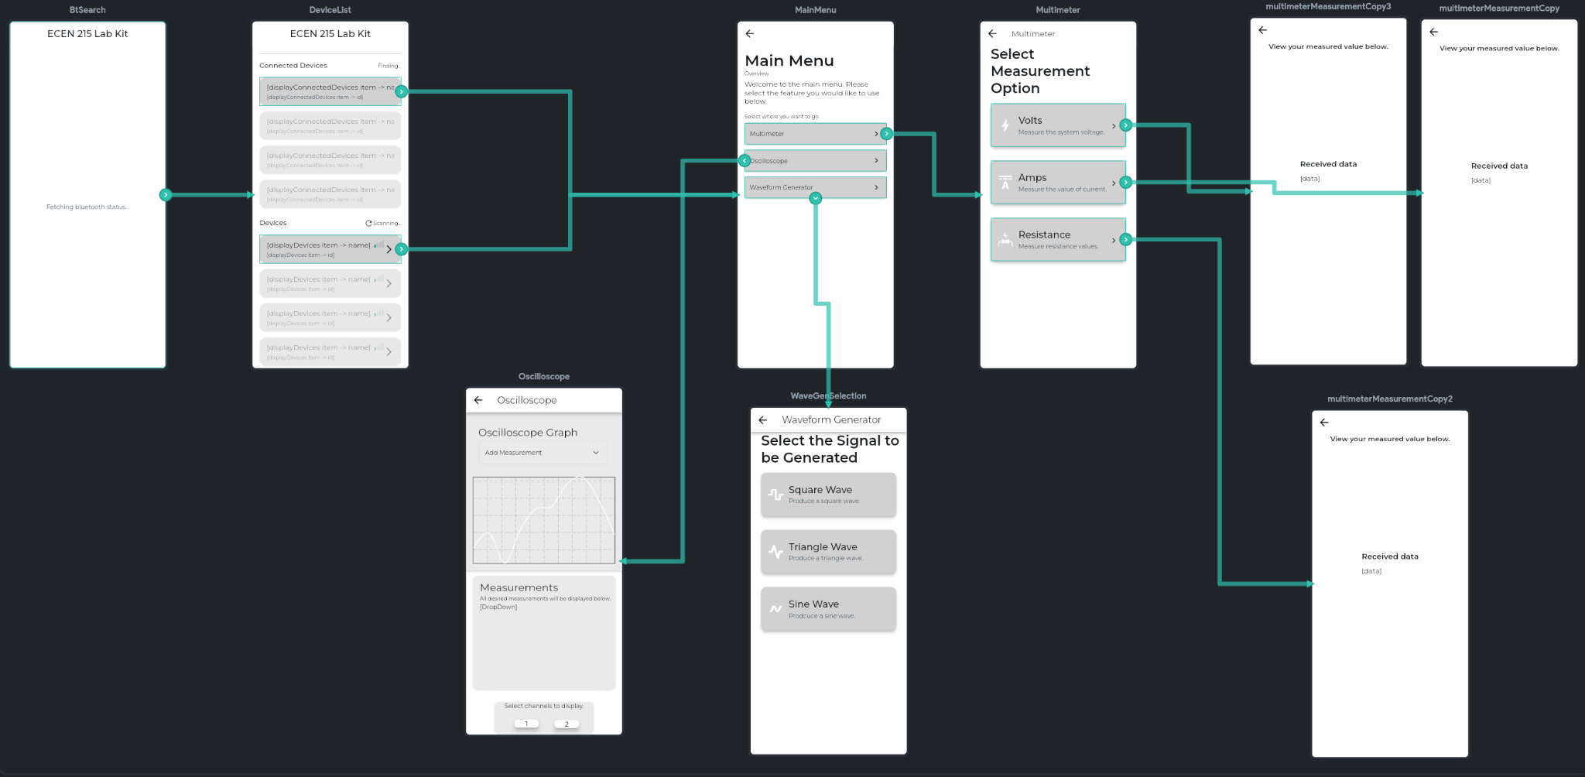

***Figure 6: Application Storyboard***

* + 1. **Emulating Application**

Once the application pages had been created the FlutterFlow project was pushed to Github and opened in VSCode. A snapshot of the project converted to code can be seen below.

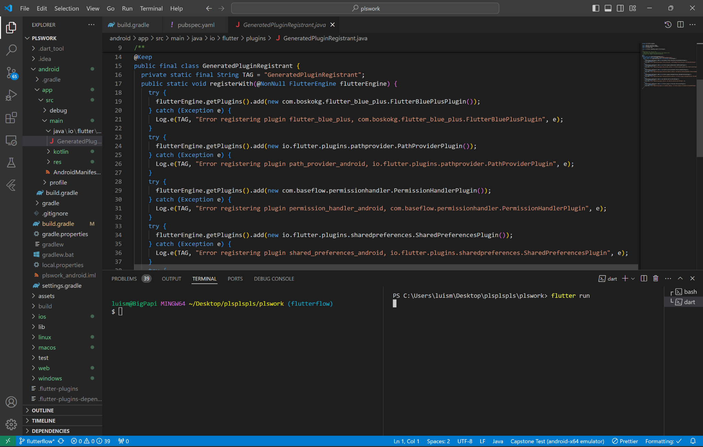

***Figure 7: Application Code in Visual Studio Code***

With the project loaded in VSCode it can now be run on an Android phone emulator. Using an emulator allows for confirmation of page design and navigation; however, because emulation is not a physical device, the Bluetooth capabilities of the project cannot be tested. The Bluetooth testing will be covered in section **3.3**. The emulated application can be seen in the figure below.

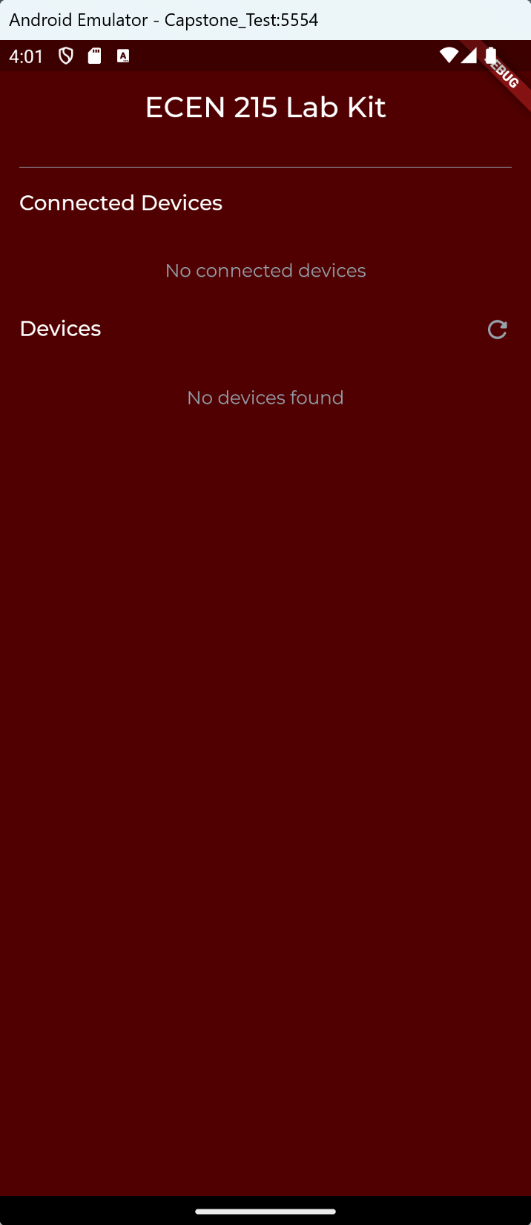

***Figure 8: Application Running on Android Emulator***

* 1. **Implementation of Bluetooth Low Energy**

Flutter does not provide Bluetooth functionality on its own, so a custom plugin is required to implement this feature. The plugin used for creating the Bluetooth functionality within this application is flutter_blue_plus. This plugin will allow for bluetooth low energy functionality.

* + 1. **Custom Code**

In order to make use of the flutter_blue_plus plugin custom code needs to be created and implemented within the FlutterFlow project. The first step in creating custom code is to establish what functions and features are desired from the application. Does the application only need to make a connection, does it need to send a message to a server, and more are questions all asked during the development process. A useful resource for discovering what functions are needed to correctly implement this plugin and Bluetooth into the application is the plugin’s documentation. This documentation covered all the necessary functions that are required to be written and implemented in order for Bluetooth to function as intended. In referring to this document it was discovered that the required functions are *connectDevice*, *disconnectDevice*, *findDevices*, *getConnectedDevices*, *getRssi*, *isBluetoothEnabled*, *receiveData*,and *sendData*. The functionality of these functions is self-explanatory by the function names, except for *getRssi*. Received signal strength indicator (Rssi) is a measure of the Bluetooth signal’s strength. After following the plugin documentation and creating the code it was put into the FlutterFlow project in the custom code section. The list of the functions that make up the project’s custom code can be seen below.

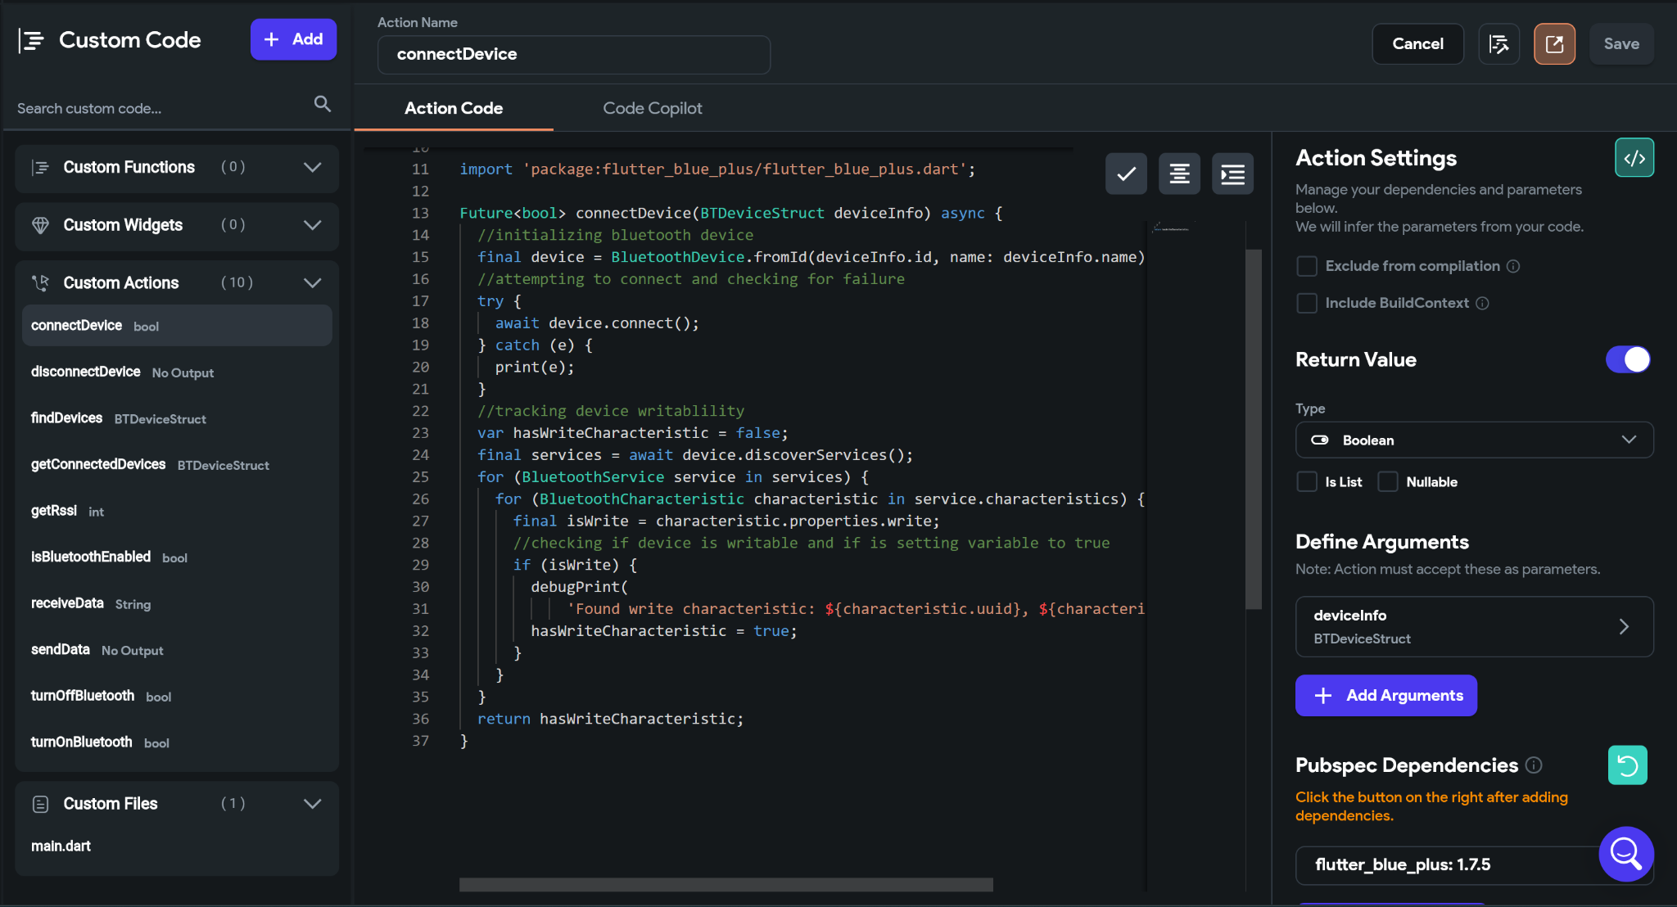

***Figure 9: Custom Code within FlutterFlow Project***

Once these functions are all in the project they can be implemented in the application through action menus and settings. One example of a function being implemented can be seen below in the figure showing an action menu for device connection.

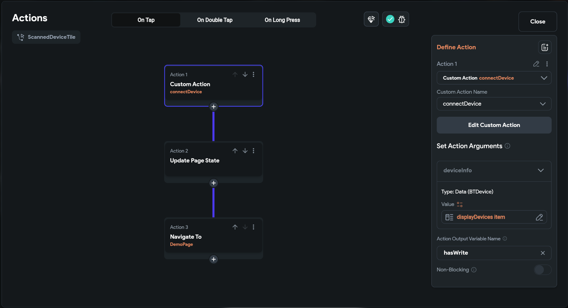

***Figure 10: Custom Code Implementation***

* + 1. **Debugging**

Due to the flutter_blue_plus plugin’s great documentation, there were not many problems to debug after implementing the custom code with bluetooth functionality. The first few issues were just simple errors, such as typos and missing semicolons. The major problem that needed to be debugged was that none of the Bluetooth functionality would work initially. The debug console kept throwing errors that did not make sense. What led to debugging this problem was deeper research on the plugin. Further research revealed that using the plugin within FlutterFlow could lead to errors if not using the correct version that is compatible with FlutterFlow. In all, the resolution to this first big problem was switching the plugin’s version from 1.32.4 to 1.7.5. Although this may seem like a huge rollback, this older version offers all functionality that is offered in the most recent version of the plugin. Once the older version was implemented into the custom FlutterFlow code the Bluetooth functionality on the application worked as intended.

* + 1. **Testing Communication**

A Motorola 6CS was used to test the Bluetooth functionality of the app. After the application had been installed on a device that had Bluetooth capabilities, the ESP32 that the app would be communicating with had to be set up. For testing purposes only, the ESP32 was configured within the Arduino IDE. Using Bluetooth libraries from Arduino a simple code was set up to send and receive messages to and from the ESP32. In order to facilitate simpler testing and debugging a demo page was temporarily added to the application. In the figures below the Motorola can be seen sending a message from the demo page to the ESP32 and the ESP32 can be seen receiving a message and sending one back within the Arduino IDE. Overall, the application was able to send messages to the ESP32 successfully, while also receiving messages from the ESP32 successfully. Once the application’s functionalities had been verified, every button and action within the application was modified to send a message to the ESP32 when activated.

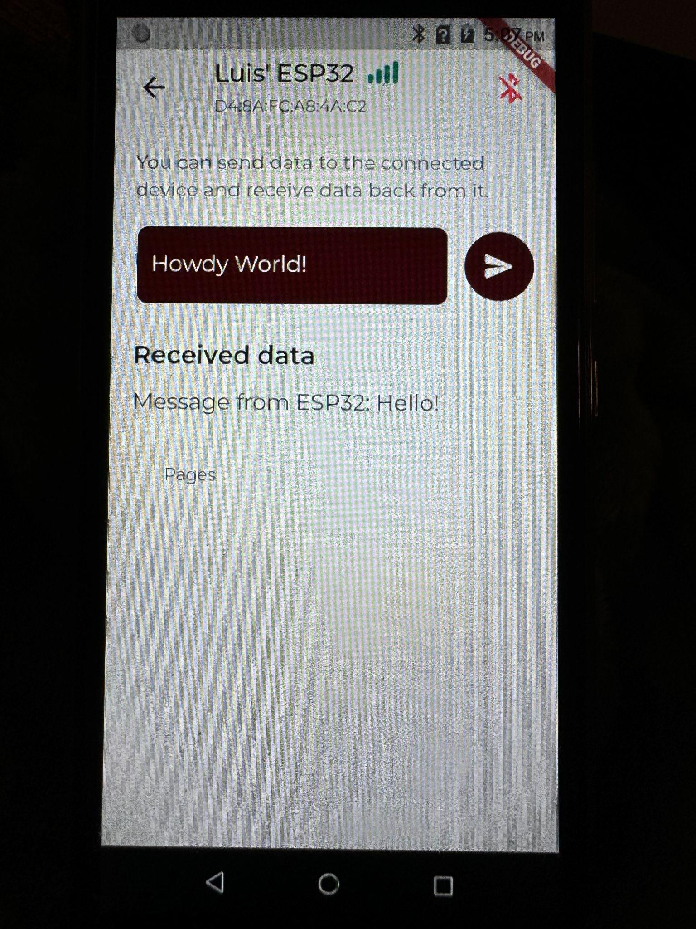

***Figure 11: Application Demo Page Sending and Receiving Messages***

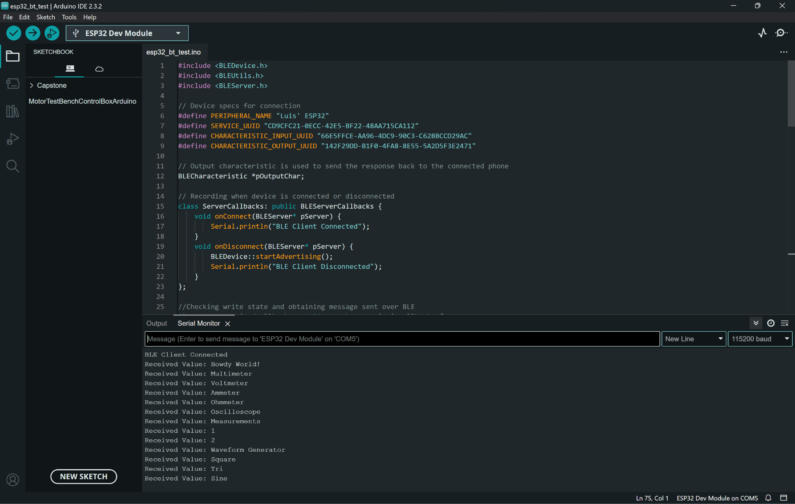

***Figure 12: ESP32 Sending and Receiving Messages within Arduino IDE***

* 1. **Subsystem Conclusion**

To conclude, the ECEN 215 Lab Kit requires a user interface that will allow students to perform their lab exercise from the comfort of their homes. Through the use of the FlutterFlow flow program, the custom flutter_blue_plus plugin with custom functions, and meticulous testing and debugging such an application has been developed. This application succeeds in performing all functions that have been desired since the conception of the overall ECEN 215 Lab Kit project. The application had been developed with the purpose of providing a responsive, attractive, and functional user interface to allow students in the ECEN 215 course to develop their skills in electrical engineering by manipulating circuit parameters, monitoring real-time data, and analyzing results with ease. In the near future this application will undergo implementation with the other subsystems within this project and be put through rigorous testing to ensure the application functions properly.

1. **Wavegenerator and MCU**
   1. **Subsystem Introduction**

For multiple labs in ECEN 215 there needs to be the generation and manipulation of multiple waveforms. The wavegen feature in our system is capable of generating 3 different shapes(sine, triangle, and square) along with a square wave at half duty cycle. The frequencies and amplitudes can also be altered for each lab. The frequency has 3 preset values of 1, 20 and 30Hz. The amplitude of each of the waves can be adjusted to 0.5, 1, and 2 Volts. These graphs can then be displayed on a smart device for further inspection.

* 1. **Firmware and Hardware**

**4.2.1 ESP32-WROOM32E-N4**

The firmware for the wavegen feature and bluetooth connection are implemented using this ESP32-WROOM-32E-N4. Originally an AD9833 wave-gen chip connected via SPI was also included in the project design but it was later removed because of the available DAC channels on the ESP32. These channels were used to produce and adjust the waveforms. The ESP32 is connected via a UART bridge.

* 1. **Software**

The code for all the firmware was done using ESP-IDF(Espressif IoT Development Framework) which included multiple libraries needed for each subsystem. The project was created using PlatformIO which is an Open-Source Ecosystem that supports systems like the ESP32.

* 1. **Wavegen**

**4.4.1 Operation**

The code for the wavegen features 3 different files, one for each of the different wave shapes. This is due to the lack of onboard memory of the ESP32 and can be mitigated in the future with the usage of a microcontroller that supports 8MB of flash instead of 4MB.

**4.4.1.2 Table Generation**

Using the <math.h> library included in ESP-IDF, a table is filled with values corresponding to either a sine,triangle or square wave with the desired amplitude. It calculates each of these values using the appropriate sin(), triangle(), or square() function provided in the <math.h> library.

**4.4.1.3 Generation Loop**

The ESP32 is only capable of producing waveforms with a certain frequency range. For the SIne wave that range is 16Hz - 500KHz, for the square wave it is a range of 1Hz - 40MHz and for the triangle wave it is 150Hz - 150KHz. To bypass this a generation loop was implemented. Inside the loop each value from the table generation is outputted to the DAC channel on the ESP32 using ‘dac_output_voltage()’. Then a delay is added to replicate the desired frequency. This process is repeated indefinitely until the program is stopper

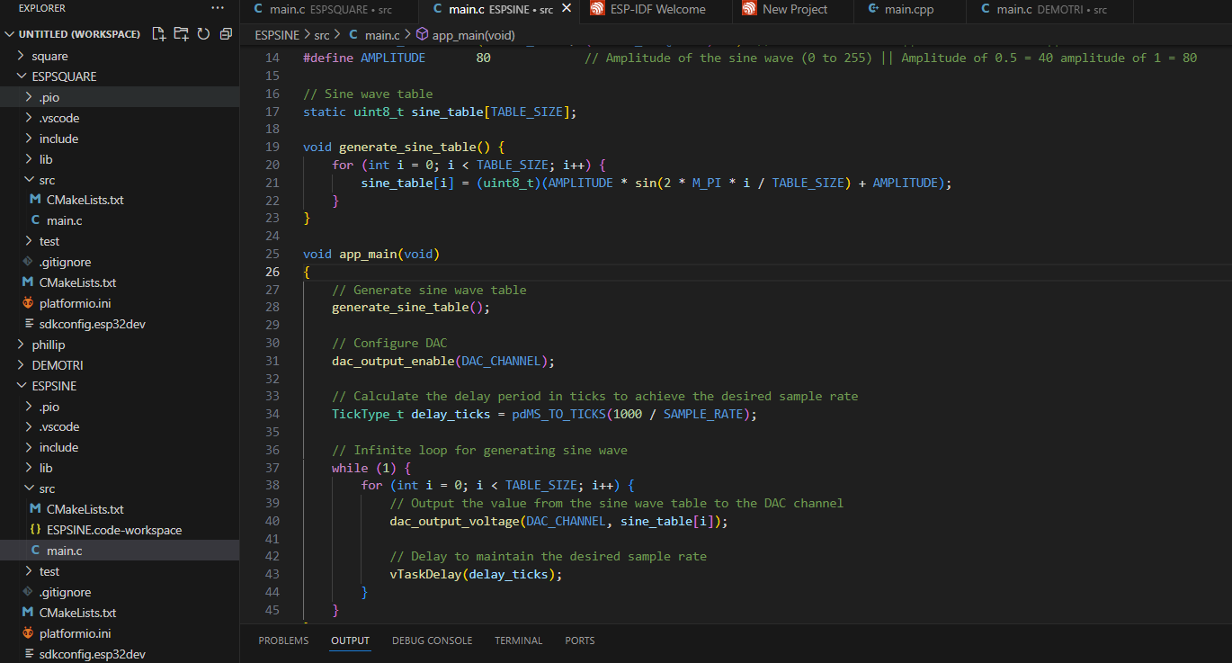

***Figure 13: ESP32 SINE Generation Code***

**4.4.2 Validation**

The code was validated and tested by using an oscilloscope connected to the dac channels of the ESP32 along with the local ground of the ESP32. The accuracy of the wavegen function was verified by the built in frequency and amplitude measuring tools already installed on the oscilloscope.

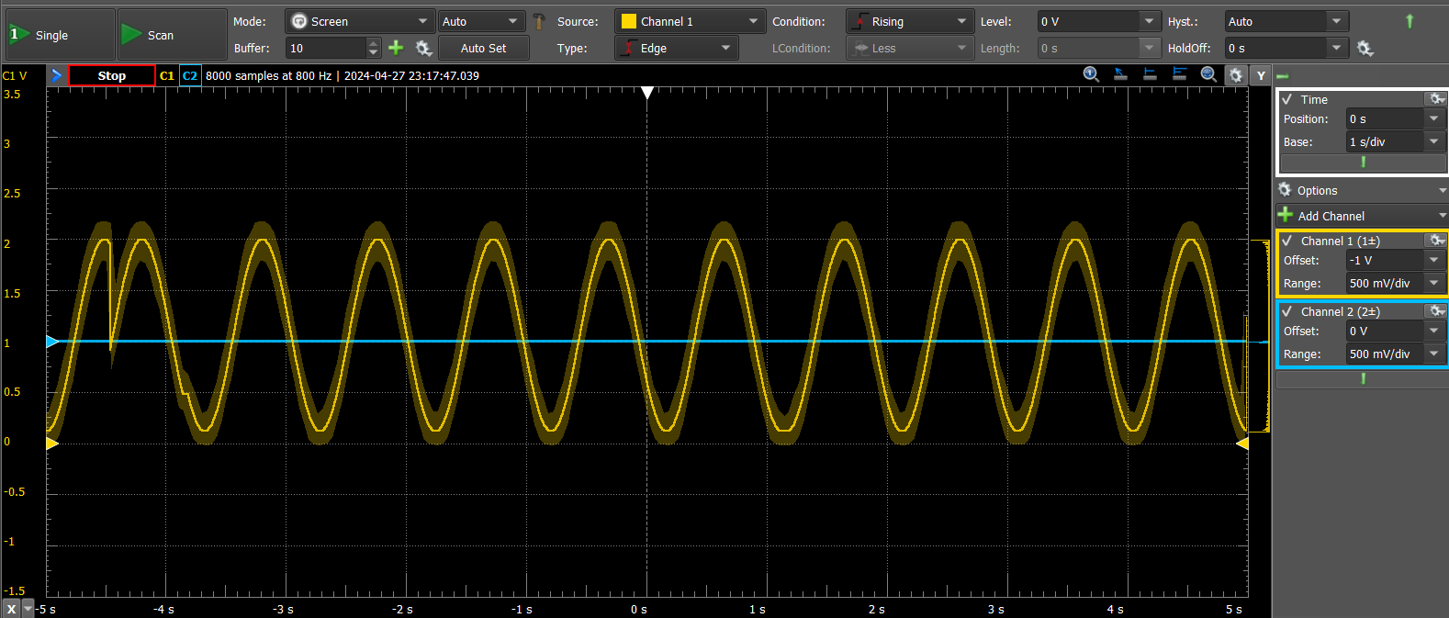

***Figure 14: SINE Wave with amplitude of 1V and Frequency of 1Hz***

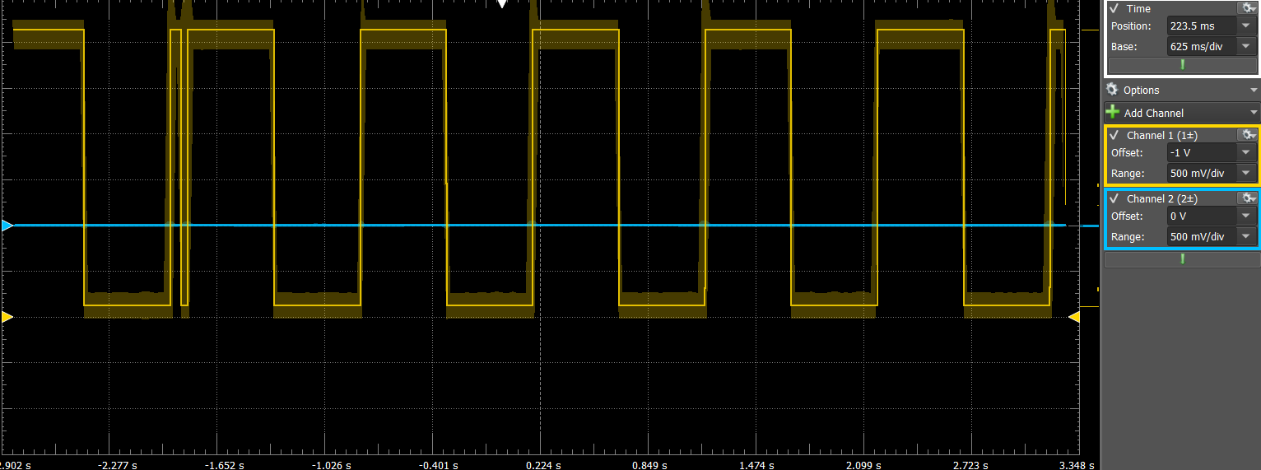

***Figure 15: Square Wave with amplitude of 1.5V and Frequency of 1Hz***

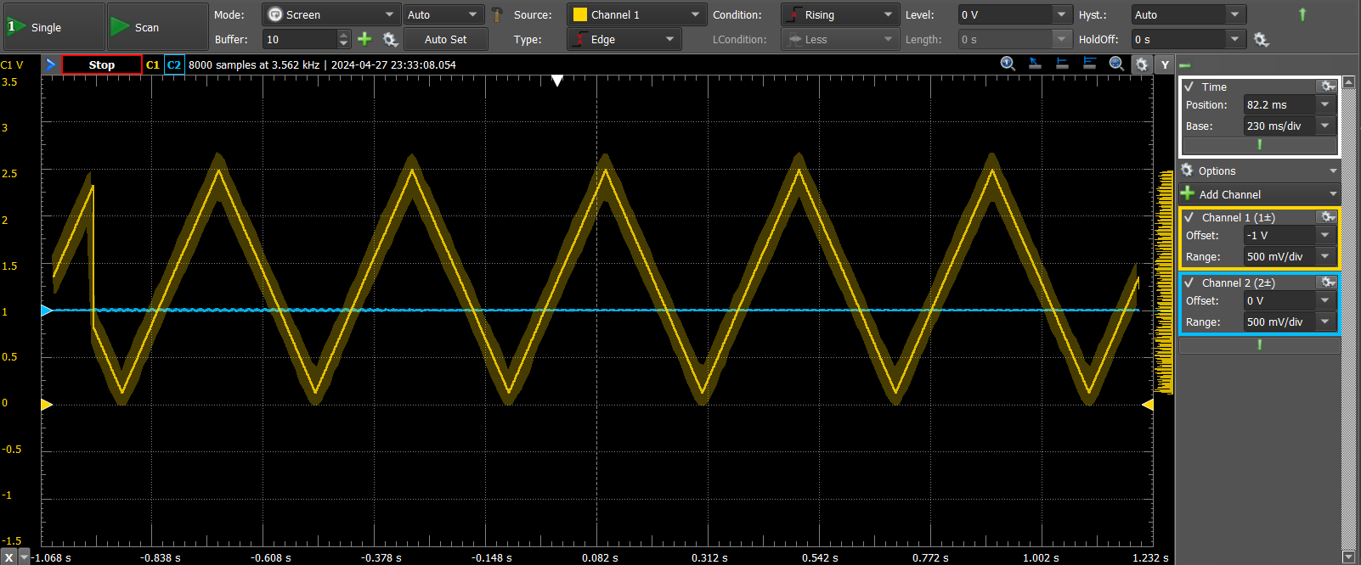

***Figure 16: Triangle Wave with amplitude of 1.5V and Frequency of 1Hz***

* 1. **Communication**

**4.5.1 Operation**

To connect the ESP32 with a smart device a BLE server is generated that allows for communication between devices, this can be used to display the wave gen function and adjust the desired parameters.

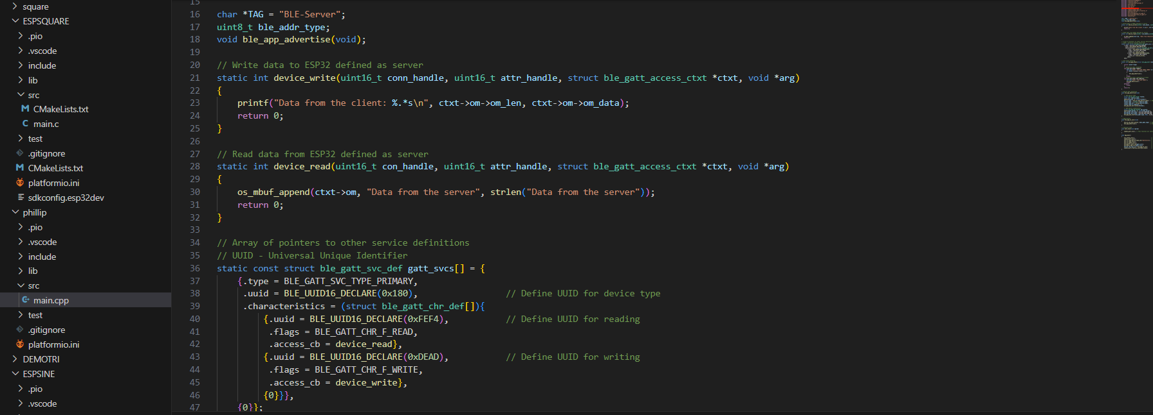

***Figure 17: BLE Server Generation***

**4.5.2 Validation**

To validate the code an android device was used to verify that the bluetooth server was available for successful connection.

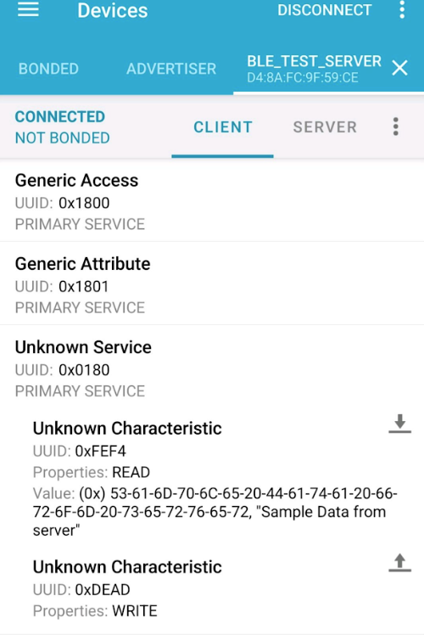

***Figure 18: Bluetooth Connection***

* 1. **Conclusion**

To conclude, the wave gen feature of the lab kit is capable of generating all the desired waveforms needed to complete ECEN 215 lab kit. The minimal noise and high accuracy allow for the correct readings needed complete any calculations. To reduce the amount of ram and files used in the wavegen subsystem, optimization of storage is needed in both the software and hardware sides of things. The wave generation function is an integral part in the completion of almost all ECEN 215 labs. Pairing this with the mobile application, this feature can be used for many other applications too!!

1. **Oscilloscope and Multimeter**
   1. **Subsystem Introduction**

The oscilloscope and multimeter subsystem are capable of reading and current, resistance, and voltage and perform as an oscilloscope with up to 60 Hz. External hardware will measure and transmit data to the ESP32 microcontroller which will process and communicate via Bluetooth data to the phone application.

* 1. **Firmware and Hardware**

6.2.1 ESP32-WROOM-32E-N4

For the firmware, both the oscilloscope and multimeter utilized the ESP32 WROOM 32E. The microcontroller contains 4 MB of flash, operates on Bluetooth 4.2, and uses the communication protocols I2C, I2S, PWM, SDIO, SPI, and UART. The microcontroller’s maximum transfer rate is 150MHz. SPI was the connection protocol used for the hardware with GPIO19 as MISO, GPIO 5 as CS, and GPIO18 as CLK.

6.2.2 ADC141S626CIMM

The ADC141S626CIMM is an analog to digital converter (ADC) which converts analog voltages into digital values. It is a differential SAR ADC with both an analog supply and digital voltage of 2.7V to 5.5 V. It has a sampling rate from 50KSPS to 250KSPS, a 14-bit resolution, a signal to noise ratio (SNR) of 84.3 dB, and communicates using a 3-wire SPI.

6.2.3 MAX4080FASA+T

The MAX4080FASA+T is a current sense amplifier that measures current across a resistor to output a voltage using the following formula:

Vout = Iload * Av * R, where Vout is the output voltage, Iload is the current across the load, Av is the gain, and R is the external resistor. The amplifier’s voltage supply ranges from 4.5V to 76V along with a gain of 5 V/V and an accuracy of 0.1%

6.2.4 TPS22918DBVR

The TPS22918DBVR is a power switch IC to turn on and off the multimeter and oscilloscope.

* 1. **Software**

Firmware code was programmed in Espressif IoT Development Framework (ESP-IDF) on the independent development environment (IDE) Visual Studio.

* 1. **Oscilloscope**

5.4.1 Operation

The oscilloscope would read a signal from the ADC and convert these measurements into a string of data which can be graphed. The input voltages would be scaled between 0 and 5 V since the ADC is unipolar. This was done by placing the input current to a 5k ohm resistor and another 5K ohm resistor would be connected to 5V. The input of the ADC would be placed between the two 5K ohm resistors. Using this configuration, the original input voltage is equal to 2 * input voltage - 5V.

The oscilloscope is capable of a frequency up to 4.5 MHz in accordance with the ADC’s specifications.

6.4.2 Validation

The accuracy of the oscilloscope was validated by comparing output string with a 60Hz sine wave. By comparing the first period, it is possible to estimate the accuracy of the system. Unfortunately, the system was unable to properly read the sinusoidal values. This is due to either poor SPI connection or heavy load.

* 1. **Multimeter**

6.5.1 Operation

The multimeter utilizes the same ADC to perform each measurement. For the ammeter, the current is passed through the current sense amplifier which outputs the voltage to the ADC. Using the equation from the MAX4080FASA+T, it is possible to measure the current. The voltmeter operates the same as in the oscilloscope. To measure the resistance, current passes from a 3.3V source through a 1k ohm resistor which passes through the resistor under test. The resistor under test is connected to the current sense amplifier and is grounded to complete the circuit. Given the current with the load is measured, the following equation determines the resistance: test resistance = 3.3V/load current – 1k ohms.

6.5.2 Validation

The test to validate the multimeter was to test the functionality of the ammeter, ohmmeter, and voltmeter. The ammeter was provided 10 mA and 0 mA, the ohmmeter was provided 100 ohms and 10k ohms, and the voltmeter was provided 5V and 0V.

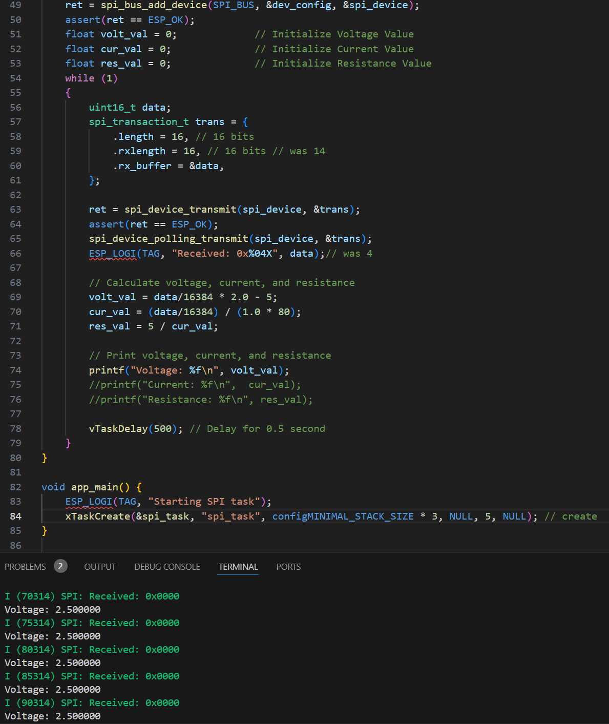

***Figure 19: Voltmeter Measurements***

* 1. **Hardware Communication**

To demonstrate that the ESP32 was capable of communicating to a phone application, a BLE server would send data to a Bluetooth app.

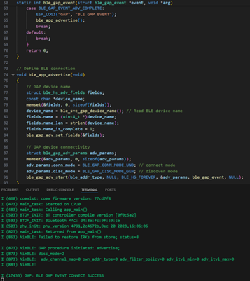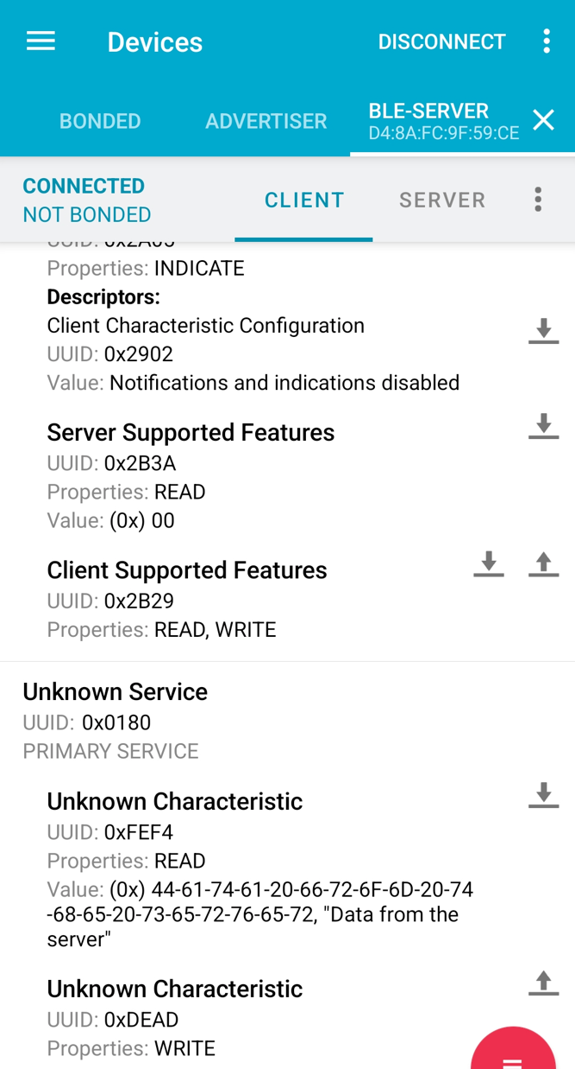

***Figure 20: BLE Server and Communication to App***

* 1. **Conclusion**

Both the oscilloscope and multimeter were shown to operate at certain parameters. The errors measured are acceptable when compared to the AD2’s readings with a few requiring more attention to fix. Issues are possible due to noise from parasitic circuit elements and trouble connecting with the . The oscilloscope and multimeter are an integral part of the overall system as it is required to properly measure and analyze circuits completed in the ECEN 215 Labs that will be displayed on the mobile application.